# 

# 

# **Facebook:** <https://m.facebook.com/groups/1108853923267022/>

# **Telegram:** <https://t.me/CDACMarathicoders>

# **LinkedIn:** <https://www.linkedin.com/groups/12633615>

# **Twitter:** [@marathicoders](https://mobile.twitter.com/marathicoders)

# **YouTube**: <https://youtube.com/channel/UCK0phPzZ0VV5ihP_0SgL9HA>

# 

# 

# 

# 

# Subject Wise Questions

Object Oriented Programming

1. What are object oriented concepts? What is difference between object-based, object-oriented and fully object-oriented language?

2. What are advantages of Object Oriented Programming?

3. What is class and object? Give real-life example.

4. What are characteristics of object? Explain them.

5. What is the need of getter and setter functions in class?

6. What is abstraction and encapsulation. Give real-life example.

7. What is polymorphism? What are its types? Explain them with examples.

8. What is function overloading? Which are the rules of function overloading? Why return type is not considered in function overloading?

9. What are different types of hierarchy? When to use which one?

10. What is the difference between function overloading and function overriding? 11. Why constructor is considered special member function of the class?

12. What is object slicing? Explain object slicing in context of upcasting?

13. What is down-casting and when it is required?

14. What do you know about association, composition and aggregation. Explain with the help of example.

15. What are different types of inheritance? Explain with the help of example. What are problems with multiple inheritance?

16. Which are the different types of design pattern? Explain singleton design pattern.

Core Java

1. What is wrapper class? What is their use?

2. Which are methods of java.lang.Object class? Which are native methods of object class?

3. What is the need of package? Which types are allowed to declare in package?

4. Why we can not declare multiple public classes in single .java file?

5. What is the difference between import and static import?

6. How can we pass argument to the method by reference? Explain with example?

7. What is the difference between checked and unchecked exception?

8. Which are the advantages and disadvantages of generics?

9. What is difference between Comparable and Comparator?

10. What is difference between ArrayList and Vector? How to use Listlterator? 11. What is fail-fast and fail-safe iterator?

12. What is serialization and deserialization? What is significance of SerialVersionUlD?

13. What is relation between Thread start() and run() method?

14. When we should create thread by implementing Runnable and extending Thread class?

15. What is functional interface? Which functional interfaces are predefined and where they are used?

16. What is significance of filter(), map(), flatMap() and reduce() operations? In which scenarios they are used?

Java EE

1. Explain Servlet & JSP life cycle?

2. What is difference between Redirect and RequestDispatcher scenario?

3. What is session tracking? How to do it in java?

4. What is hibernate? Explain hibernate architecture.

5. Explain hibernate entity life cycle?

6. What is the difference between get() and load() of hibernate?

7. How can we call stored procedure in hibernate?

8. What is 10C and Dependancy injection?

9. What is auto-wiring? Which are the types of auto wiring? What if prototype bean is auto-wired in a singleton bean?

10. Explain spring bean life cycle. Explain spring bean scopes.

11. What is use of @Transactional? Why it should be used on service layer?

12. Explain Spring MVC life cycle?

13. What is the difference between SOAP and REST? What is significance of RestController?

14. What is Spring Boot? What do you mean by opinionated defaults? How auto-configuration works?

15. What is significance of @CrossOrigin? How it works?

O.S.

What is the main purpose of an operating system? Discuss different types?

What is a socket, kernel and monolithic kernel ?

Difference between process and program and thread? Different types of process.

Define virtual memory, thrashing, threads.

What is RAID ? Different types.

What is a deadlock ? Different conditions to achieve a deadlock.

What is fragmentation? Types of fragmentation.

What is spooling ?

What is semaphore and mutex (Differences might be asked)? Define Binary semaphore.

Belady’s Anomaly

Starving and Aging in OS

Why does trashing occur?

What is paging and why do we need it?

Demand Paging, Segmentation

Real Time Operating System, types of RTOS.

Difference between main memory and secondary memory.

Dynamic Binding

FCFS Scheduling

SJF Scheduling

SRTF Scheduling

LRTF Scheduling

Priority Scheduling

Round Robin Scheduling

Producer Consumer Problem

Banker’s Algorithm

Explain Cache

Diff between direct mapping and associative mapping

Diff between multitasking and multiprocessing

DBMS

What is DBMS ? Mention advantages..

What is Database?

What is a database system?

What is RDBMS ? Properties..

Types of database languages

ACID properties (VVVVV IMP)

Difference between vertical and horizontal scaling

What is sharding

Keys in DBMS

Types of relationship

Data abstraction in DBMS, three levels of it

Indexing in DBMS

What is DDL (Data Definition Language)

What is DML (Data Manipulation Language)

What is normalization ? Types of them ..

What is denormalization ?

What is functional dependency ?

E-R Model ?

Conflict Serializability in DBMS ..

Explain Normal forms in DBMS

What is CCP ? (Concurrency Control Protocols)

Entity, Entity Type, Entity Set, Weak Entity Set..

What are SQL commands ? Types of them..

Nested Queries in SQL ?

What is JOIN .. Explain types of JOINs

Inner and Outer Join

Practice sql queries from leetcode

Diff between 2 tier and 3 tier architecture

Diff between TRUNCATE and DELETE command ..

Difference between Intension and Extension in a DataBase

Difference between share lock and exclusive lock, definition of lock

Computer Networks

Define network

What do you mean by network topology, and explain types of them

Define bandwidth, node and link ?

Explain TCP model ..

Layers of OSI model

Significance of Data Link Layer

Define gateway, difference between gateway and router ..

What does ping command do ?

What is DNS, DNS forwarder, NIC, ?

What is MAC address ?

What is IP address, private IP address, public IP address, APIPA ?

Difference between IPv4 and IPv6

What is subnet ?

Firewalls

Different type of delays

3 way handshaking

Server-side load balancer

RSA Algorithm

What is HTTP and HTTPS protocol ?

What is SMTP protocol ?

TCP and UDP protocol, prepare differences

What happens when you enter “google.com” (very very famous question)

Hub vs Switch

VPN, advantages and disadvantages of it

LAN

Technical Round

Write a binary search program

Method Overloading vs Overriding

Collection Hierarchy

Which collection is thread safe

What is Load balancer

WAP to add 2 numbers without + operator

Explain project

Spring vs Spring Boot

Spring Boot Annotations

What is REST

Write a REST API

Write a select query to print 3rd highest salary

Again above query without using limit

Difference between SQL and NoSQL database

What do you know about System Design

What is CI/CD pipeline

Explain React

HR Round

Tell me about yourself

Explain your College and CDAC project, what challenges did you face and how did you overcome those challenges?

Why did you choose this company

Do you have any questions for us

Coupa

Coupa first round (Rahul bhadwar )

Rahul bhadwar

Coupa first round

Oops concept

Polymorphism in details

Tcp protocol

Deadlock

Unique email id entry in project

Overloading and overriding

Friend function

Different database

Oracle vs mysql

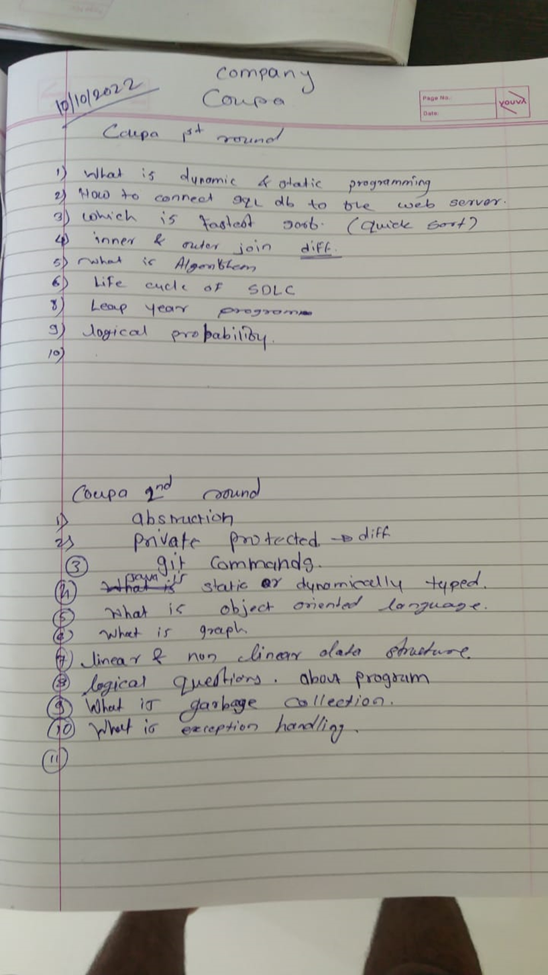

**Gaurang Shende**

Coupa 1st Round

Design database for Blog website

Tables, columns, data type, relations, keys.. etc

Gave 2 codes asked for output

Asked reason behind output

Gave me problem to solve

Num is given eg 7

Need to print star pyramid

When the total no of stars reach 7 stop

For Eg:

*

**

***

*

Difference between overloading and overriding

Can we overload within the class

Some more Core Java based questions

Tell me about your project

Round 2

What is Queue

What is Stack

Code snippet for Reversing word

Code snippet for Reversing sentence with commas and space

Why we use Linked List

How to traverse Linked List

What is Binary Search

Pseudo Code of Insertion Sort

Write a Sql query to get name of emp with 3rd highest salary

Explain you project database design

Explain relationships

Why do we use index on database

Explain your project

Asked question about Project: why did you do this? And cross questioning answers

Asked about the design plan of project

How did you handle XXX question on project

How did you handle state management

Tell me about your 2nd project

3rd Round

Tell me about yourself in 3 Lines

Write a code for finding max from 3 numbers

Try to Optimize this code

Showed 2 code and asked about the output

Asked why we use index on sql database

Advantages of index

Disadvantages of index

Tell me about your project

Explain the sql database schema design

Cross questioning the design

Do you know about cloud computing

How did you deploy website on AWS step by step

What issues did you face while deploying website

Tell me about where you were born and about your family background

Coupa (mandar)

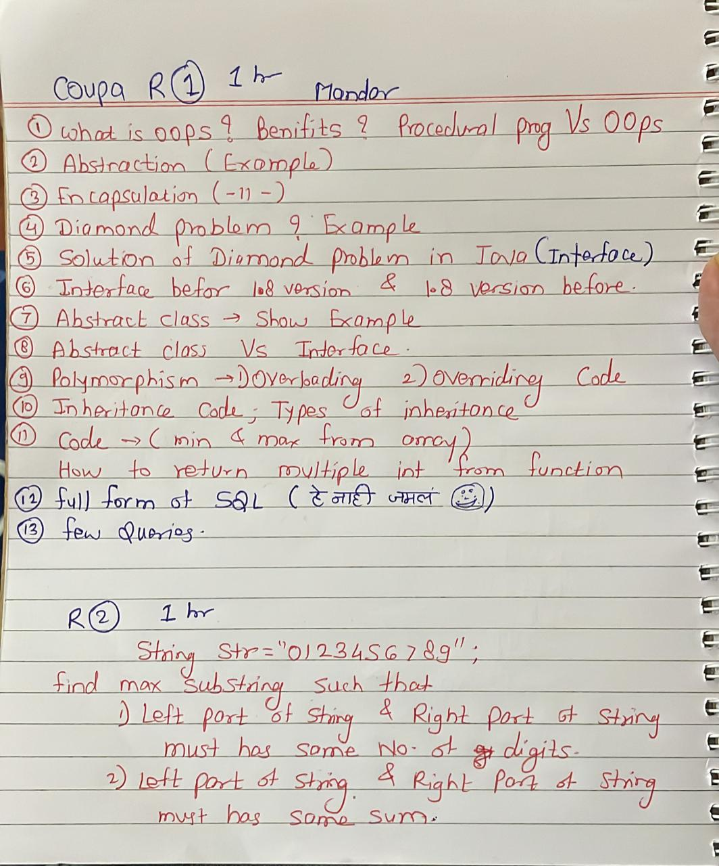

Coupa

1st: 10/10/2022

Intro

OOPs

OOPS details

constructors

exception handling

one table scenario: basically they test you Join knowledge

String reversal with omit the vowels : how many ways, any other way to reduce complexity

array: desc order but all 0s will at first place

-------------------------------------------------------------------------------------------------------------------------------------------------------

L1: 11/10/2022

Intro

Java basics

Oops major, minor

checking knowledge of collection, object class

sql : 2nd highest

palindrome wish scenarios

new added java 8 features(also in interface like default and static methods)

They check deep knowledge of programming/database

-------------------------------------------------------------------------------------------------------------------------------------------------------

L2: 12/10/2022

Intro

non technical like my past company experience

Heap stack theory(in deep: where it lie in computer)

Reference of objects in deep

e1 is obj, e2 is obj

if e2=e1

e1.i=5000

e2.i=?

and why?

e1=Null

e2=?

Convert number to work

1= one

22= Twenty two

868= eight hundred and sixty eight

Code for undo redo

1234 => 123

Undo 1234

1234=> 123=>1235

undo 123 undo 1234

redo 123 redo 1235

Coupa Software

1st Round : Technical

1. Introduce yourself

2. How you rate yourself in coding?

3. Tell me something about your project and what technologies you have used?

4. Why you have used MySQL in project?

5. Have you worked on any Linux OS? Do you know the concepts of Operating System?

6. Where did you deploy your project?

7. Suppose, while deploying your application is not working, how will you tackle this?

8. Explain annotations

9. While deploying if tomcat is not working, how will you resolve that?

10. Tell me about binary tree.

11. Write a program to reverse a number. Explain each step.

12. Do you have experience of using Cloud (AWS or any other)?

13. Which project you have deployed on AWS?

14. How did you access AWS?

15. Do you know S3? (It is Amazon Simple Storage Service)

16. Program to count the wovels in a given string.

17. How to check running processes in machine?

Checked my Resume at last

18. Do you want to ask anything?

2nd Round : Technical

1. Can you recall the questions asked in test?

2. Do you know anything about Cloud Computing?

3. Purpose of using Cloud Computing?

4. How do you access cloud services?

5. What is SSH?

6. Have you used Linux?

7. What is Bash shell?

8. What is shell scripting?

9. Programs you have done in shell scripting

10. Different commands in linux.

11. Explain each OOP concept with real life example.

12. Explain in detail different blocks used in exception handling

13. Write a program to get the count of occurence of unique word from a given string. (after giving solution, told me to use different logic)

14. Given an array, rotate the array to the right by the k steps, where k is non-negative.

example:

Input: nums = [1,2,3,4,5,6,7], k = 3

Output: [5,6,7,1,2,3,4]

Not to use array, shift/unshift, delete/pop etc methods

No extra separate array

Need to share screen, write program on notepad, and explain each step while writing code.

15. What do you know about Databases?

16. Explain the properties of RDBMS

17. What is System Data and System architecture?

18. Suppose I want to build a Library Management System, how will you design it?

(Need to explain the whole process, from requirement gathering, wireframe design, making SRS, Use-case diagrams, Databsse design, normalizing tables, process of configuring database connection with back-end, what layers and classes will be used in backend, annotations, data flow, connecting to front-end and all remaining)

19. Do you have any question for me?

3rd Round :

Technical:

1. Introduce yourself

2. Why did you choose CDAC as your background is non-IT?

3. Is CDAC your first exposure to programming ?

4. Tell me the progam to access the text file and count the occurences of each unique word present in the file.

5. Write a program to find the missing from array with length 10 thousand having elements ranging from -3000 to 7000. Explain time complexity for each possible situation.

6. How to implement Queue data structure using stack? (After telling my logic, told me to use another approach as my approach had many iterations which were time consuming)

Puzzles:

1. You have given 3 boxes, one contains Red balls, one contains Yellow and the remaining one contains mixture of both Red and Yellow. Each box has label of colour but none of them is correct. You have to pick only one ball from any box and guess what should be the correct label for each box

2. You have two containers, first one with 3L capacity and second with 5L. You need to measure exact 4L of water using these two containers. (You can not make any kind of marking on containers)

Coupa 1st Round

short introduction

Explain project and role

What Api's implemented in project

how Controller knows that return value should be JSON object

Diff between Hibernate and JPA

If we do not have hibernate jar but have used JPA what error will it give- compile time or runtime

diff between session and cookie

Why React JS

which sorting algorithm is best

difference between array and linked list

what are type of trees, application of red and black tree

diff overriding and overloading

Coupa 2nd Round

short introduction

Explain OOPs concepts

OS- what is semaphore

what is multithreading

SQL:

- Find all the user from employees table (id, name , email)

select * from emploees;

- Find first 50 the employees from employees table sorted by email

select * from employees

order by email

limit 50;

- Another tables employers (id, name, address)

and a bridge table employers_employees (employee_id, employer_id)

Give me name of the employers having Employee as first name = "Sanket"

select e.name

from employers e join employers_emplyees b on e.id=b.employers_id

join employees emp on b.employee_id=emp.employee_id

where emp.name="Sanket"

- Infix to Postfix expression:

The infix expression : x ^ y / (5 - z * 6) + 2

Output Postfix expression:

xy^/(5-z*6)+2

xy^5z6*-/2+

Using stacks: xy^5Z6*-/2+

- Type of Sorting algorithms:

Sort numbers: 30 20 10 50 100 70 40

Bubble Sort:

30 20 10 50 70 100 40

20 10 30 50 70 40 100

10 20 30 50 40 70 100

10 20 30 40 50 70 100

int temp;

for(int i=1;i<n;i++)

{

int s=0;

for(int j=i-1;j<n-i-1;j++)

{

if(a[j]>a[j+1])

{

temp=a[j];

a[j]=a[j+1];

a[j+1]=temp;'

s++;

}

}

if(s==0)

break;

}

// FizzBuzz Problem:

// Iterate over 1 to 100

// Print fizz if no is div by 3

// Print buzz if no is div by 5

// Print fizzbuzz if no is div by 3 and 5 both

StringBuilder s="";

for(int n=1;n<100;n++){

s="";

if(n%3==0)

{

s="fizz"

}

if(n%5==0)

s=s.append("buzz");

if(a.length()>0)

sop(s);

}

round 3

detailed introduction

why to add @Override on overridden method

what you consider your biggest achievement

what is biggest blunder you have done

what run dynamic binding or late binding explain with example in IDE

find longest substring without repeating characters solve in IDE

puzzle - 5 boxes containg multiple balls , 4 boxes have balls of 10gm weight 1 box have 9 gm of balls,given digital weight measuring machine what is least number of attempts required to identify box with 9gms. Ans -1 attempt - take 1 ball from 1st box 2 from 2nd and so on- now total balls are 1+2+3+4+5= 15, if all were 10gm then total would be 150gm, so in case 1st box have 9 gm balls then weight will be 149 as one ball of 9gms

similarly if 2nd box have 9gm balls then as there are 2 balls of 9gm total weight will be 148gm and so on we can find accordingly .

given 2 sorted array how will you store these 2 arrays in resultant sorted array - pseudo code

given string of int from 0-9 ("1231238") find max sub string with below condition

1. when devided in equal parts sum of both left and right substrings should be equal

e.g 123 | 123 ==6 so result=123123

Sagar Bhilawade

Coupa round 1::(Taken by 2-3 years experienced Guy)

What is oops?

What is abstracttion?(while giving ans i gave an example my specs)

Make a class of your specs ?Fileds and Methods

Explain Project in short?

Write a code to print right angle Triangle?

Then little bit on data structure like linked list stack queue just concepts?

Coupa Round 2::(Taken By 10-12 years experienced guy)

How internet works?(starting 5 minutes conversation )

Again little bit on oops

Write a code to print all palindromic substrings from a string? e.g abaaba ans: aba aba abaaba

Write a query to get a employess who is not manager..(Table Structure:: empno,ename,mgrno)

Explain a project.

Scenario:(almost 25-30 min discussion)

Suppose Google assigned you as tester for gmail .What things /Functionality you will check?

Coupa Round 3::(Taken By VP)(like hr +technical)

Introduction.

Why Civil to IT?

Explain Project.

What challenges You have faced in your project?

What Was your role in project?

Concepts of Database?

What is normaliazation explain why we need it?

Little bit on Data Structures?

What is rest?

What is JUnit Test?

What is collection?

(Then i asked at last sir how was it? Then he replied You need to improvise in some things but u can make that with my teammates...But still he reajected me😔😔)

____________________

Coupa (Shubham Pisal sunbeam)

Round 1

1. Tell me brief about Your Project and Your Role in Project ?

2. How does JWT token work explain such as NONTECHNICAL guy will understand?

3. What JSX?

4. What types of components are in react and which will you use?

5. What are hooks in react ?

6. What are props?

7. What is redux ?

8. What is oops concepts ?

9. What is class ?

10. Difference between class and objects?

11. What is constructor and its types?

12. What is destructor ?

13. What is Access Specifiers?

14. how will make sure a class cannot be extended further ?

15. how can you add some methods to a final/sealed class ?

16. Asked to perform 1st Normalization form on some data?

Round 2

1. How was your 1st Round ?

2. Difference between http and https ?

3. What is TCP protocol?

4. What are layers in TCP/Ip protocol?

5. How will you make a website available to users ? (Asked How will you deploy website without using

deploy word)

6. What happens when we enter some website address in searchbox of browser ?

Read How DNS works (Domain Name System ) and how browser gets ip address from DNS

7. what is inner join and outer join?

8. write an left outer join on a table say t1 and t2?

9. Asked how will you find max and secondMax element from array ?

10. If i gave you a number then an array will be having number from 1 to that number But 1 number will be

missing How will you find missing number ?

example 10 and array {2,5,1,3,4,6,10,7,8} here missing number is 9 how will you find it

Based on answer given to above questions he asked the following question

7. Find a longest subArray having maximum sum from an array ?

Here is Question

Round 3

1. Introduce Yourself ?

InterviewQuestions.md 10/15/2022

2 / 2

2. Why Mechanical to IT ?

3. Why did you choose Mechanical ?

4. What advantage you have over an IT student as you belong to mechanical?

5. which programming language you like and which you don't like?

6. what is difference between c and c# or Java?

Asked to justify answer

7. How will you sort array (Choose which you think best sort is)

8. Why do you think Quick sort is best ?

9. What is divide And Concur ?

10. How will you divide Array in Quick Sort ?

11. What operations we perform in Quick sort?

12. How to choose pivot in quick sort ? (last first or middle element )

13. What is time complexity of Quick sort ?

14. When worst case came in Quick Sort?

15. How will you avoid worst case in Quick Sort?

16. How Merge sort works ?

17. How we merge arrays in merge sort?

18. What is time complexity in merging multiple sorted subArrays ?

19. How multiple subarrays can be merged more effectively (This question can be ignored It uses binary

tree or binary heap)

20. Why do you think quick sort is better than merge sort?

21. Best options than merge and quick sort?

22. What is time complexity of recursive code for fibonacci series ?

f(n)=f(n-1)+f(n-2);

look for tree method to find time complexity of recursive method

23. what is better way to do fibonacci series ?

iterative (By loop)

23. what is time complexity of iterative code for fibonacci series ?

24. what is space complexity of iterative code for fibonacci series ?

coupa

**Student Name :** **Gaurang Shende**

Coupa 1st Round

Design database for Blog website

Tables, columns, data type, relations, keys.. etc

Gave 2 codes asked for output

Asked reason behind output

Gave me problem to solve

Num is given eg 7

Need to print star pyramid

When the total no of stars reach 7 stop

For Eg:

*

**

***

*

Difference between overloading and overriding

Can we overload within the class

Some more Core Java based questions

Tell me about your project

Round 2

What is Queue

What is Stack

Code snippet for Reversing word

Code snippet for Reversing sentence with commas and space

Why we use Linked List

How to traverse Linked List

What is Binary Search

Pseudo Code of Insertion Sort

Write a Sql query to get name of emp with 3rd highest salary

Explain you project database design

Explain relationships

Why do we use index on database

Explain your project

Asked question about Project: why did you do this? And cross questioning answers

Asked about the design plan of project

How did you handle XXX question on project

How did you handle state management

Tell me about your 2nd project

3rd Round

Tell me about yourself in 3 Lines

Write a code for finding max from 3 numbers

Try to Optimize this code

Showed 2 code and asked about the output

Asked why we use index on sql database

Advantages of index

Disadvantages of index

Tell me about your project

Explain the sql database schema design

Cross questioning the design

Do you know about cloud computing

How did you deploy website on AWS step by step

What issues did you face while deploying website

Tell me about where you were born and about your family background

**COUPA**

Name: Kaustubh Pathak

1st interview

Write an sql query to find the 3rd highest salary from an employee table. Are there any other ways to do the same thing other than your query?

Given an array write a java program to sort only those elements which occur more than once in that array. Explain the logic and the time complexity. Is there any way to optimize this code?

Given two arrays check if elements of one array are present in the second array sequentially. Explain the logic and the time complexity. Is there any way to optimize this code?

What are maps? Explain their working.

What is Http. Explain the difference between http and https.

2nd interview

How would you design a UPI payment system like paytm or Google pay from scratch. (In this there were questions at every step that why would you do it like this... Is there any other way to do the same thing. In which ways can the system fail. )

Questions regarding hosting the project on cloud.

3rd interview

Initial questions about my background of mechanical engineering and my government exam preparation.

Explain the database schema of my project.

In my project database i was asked to write a query which required joining 3 tables.

What are sql joins. What are different types of joins

Estimation problem - Estimate the number of apartments in Pune.

Give me two reasons why should we hire you.

Few questions about my hobbies.

-introduction

-array program to find duplicate element(cross question) and use different method(reduce time complexity)?

-oops concept in details and e.g(cross question) and where you use in project?

-explain construtor and e.g?

-one program solution(same code modified 3 time)and cross question?

-database

create table?

write query ?

-bubble sort program(cross question)?

-overloading?

-tree ?

-project

technology used?

Cdac Pune

Spring MVC

features of java

already banavlelya table madhe jar add karaycha asel coloum like Date of birth tar kasa karaycha

annotations you used in program what do they do

starting la combined 3 questions hote, introduce yourself, you project and all the annotations you used in detail

CDAC Pune 2022 (Bhakti)

Introduce yourself

Detail description about project

Group by

Delete duplicate values

Add column

Remove column

Auntheticate vs authorization

Spring bean

How you connected your dayabase

What is model view

Add foreign key constraints

Which are constraints in database

Primary key vs unique key

What is foreign key

Application context

What is IOC

What loose coupling

**CDAC PUNE** 2022 (gargi nigade)

1. Tell about yourself.

2.Project in detail.

3. Your role in project.

4. What technology are you comfortable in ?

5. What is springboot ?

6. What is pom.xml?

Explain it's architecture.

7. What build is used in spring boot.

8. What is maven and it's architecture .

9. What version of java have you used ?

10. Java 8 features

11. What are defender methods ?

12. What is AOP.

13.What is intercepter ?

14. What is postman ? Why have you used it ?

15. How do you run Spring boot Application .

16. What are ddl and dml commands.

17. Types of joins.

18.What is natural join ?

19. What is cursor ?

20. What is normalization ?

What is normalisation?

what are filters?

What is procedure?

Its advantages

Sql injections

And how to prevent

what is bootstrap,

truncate vs delete

grant command

**CDAC PUNE** (shubham varal)

What is normalisation?

,what are filters?

What is procedure?

Its advantages

Sql injections

And how to prevent

what is bootstrap,

truncate vs delete

grant command

Can program run without catch block

Student Name: Vaibhav Patil

Company Name: Cdac Pune

Round: First/second/third/HR (select one)

Questions:

1. Explain Collection Hierarchey.

2. Explain Synchronization.

3.Hasmap vs Hashtable.

4. Explain Cursor,trigger,View.

5. In truncate Rollackback Possible or Not?.

6. TYpes of join.

Student Name: Kishor Janjal

Company Name: cdac Pune

Round: Direct Interiew

Questions:

Q1 Introduce Yourself and explain about your Project

Q2 4-5 Question on Project Flow & Your Role In it

Q3 What is Spring Intercepter

Q4 What is CLI in Spring boot

Q5 What is Callback Function

Q6 What is Promise

Q7 Why did you choose Node Over Spring Boot

Q8 What are key Component Of Spring

Q9 What is Dependency Injection

Q10 what is application Context & Bean Factory

Q11 What is AutoWired

Q12 what is Command For SQL i. Create Index ii. Delete Column iii. Delete Data

Q13 Why did you choose Expressjs

Q14 what are Bind Variable in MYSQL and is they available in Triggers Only

Q15 What is Component Scan and Context Annotation

Q16 What is Static Binding

Q17 Explain MVC

Q18 Explain Request Flow In MVC

Q19 Explain Controller flow in Frontend

**Interview Questions of Herald Logic**

Introduce yourself

JAVA:

Constructor?types

Main pillars of java

Abstact class/inteface

Types of inheritance/polymorphism

Exception handling?

Arraylist vs vector

Hierarchy of collection

Multithreading (ways of creating thread, how?)

Final keyword

Write a program to reverse a string

To check string is anagram or not

DSA:

stack/queue

Searching algo (types,with complexities)

Write a syntax to find middle element linkedlist(same with less complexity)

Reverse Linkelist logic

DBMS:

What is joins?

Types of joins?

Normalisation?types?

J2EE:

Spring vs Springboot?

Any 10 annotation with use

Use of hibernate

Project:

Which technology?

Flow of project?

Your role?

Which design pattern?

Normalization level?

And MySQL queries

**CDAC PUNE**

Intro with project n technology

Contructor

Static binding

Abstraction

CDAC Pune March 2022 Interview Questions

Explain your dac project

Your role in Project

Project related few questions(related my role)

Software testing

Types of testing

What is functional testing

Do you know about

Manual testing and Software testing

Are you interested in testing profile

Do you know about software testing

Have you written test cases ??

**CDAC PUNE**

Student Name: Alshifa Mansuri

Company Name: Cdac Noida

Round: First (Direct IV) (select one)

Questions:

1.)CDAC Noida Interview Questions :

2.)What is constructor and its types

3.)What is Overloading and overriding

4.)What is rest controller and rest api

5.)What is mapping and its types

6.)What is the flow of any request in Spring

7.)In case you have to upload a file in a form what mapping is used and what type of attribute is used and how it is stored in database

8.)How many tables are there in your project

9.)Till how many level of normalisation have you acived

10.)what is 3rd normal form

11.)what is @configuration annotation

12.)Do you have github profile and what is use of github

13.)what is use of docker

14.)What is maven used for

15.)Why is main method static in java

16.)what is interface

17.)what is abstraction

18.)How spring application runs

TIAA

mol dada marathi coders:

What is OOP

Explain pillars of Oops

Explain data hiding

Collection hierarchy

What is the implementation of list

What is difference between hashmap and hash table

What is the internal working of hash table and hash map

Difference between map and set

Features of java 8

What is stream API

Write code for stream API

What is functional Interface

What is new things in interface after java 8

What will happen when we write 2 default methods in functional interface

What is singleton class

What is exception

When to use throw throws

Too much scenario based questions on exception handling

What is linked list

When to use linked list when to use arraylist

What is searching sorting

Scenario based questions on searching and sorting

What is try with resource why to u…

[3:46 PM, 10/11/2022] Amol dada marathi coders: CDAC Pune March 2022 Interview Questions

Introduce Yourself

Explain your dac project

Your role in Project

Project related few questions(related my role)

What steps you took to design your database

How to achieve foreign key in MongoDb

Operator Overloading

Spring MVC structure

Function Overloading

Imagine example of function overloading in your project and if any, explain

Springboot Advantages over Spring MVC

ReplicaSet in MongoDB

Primary Secondary ReplicaSet

Did You Use Covered Queries in your project

Which Version Control System you used (Github)

Github is Centralized or Decentralized Version Control System

Their Advantages

TIAA - L1

1) briefly introduce yourself

2) which java version u studied

3) features of java 8

4) tell mi oops concept

5) describe encapsulation

6) describe abstraction

7) write code for palindrome number

8) given one array and ask to print prime number

9) given one array and ask to remove duplicate in array

10) what is exception

11) how to handle exception

12) can we write catch block without try

13) can we write try without catch block

15) difference between throw and throws

16)what is multithreading

17) after thread start which method is called

18) how to achieve multithreading in java

19) what is spring boot

20) advantage of rest api🤔

21) @service and @controller annotation

22) what is dependency injection

23) which mapping u used

24) get vs put

25) what is post mapping

26) linear vs nonlinear data structure

27) operation of stack

28) what is complexity

29) if two for loop is there then what is time complexity

30) how to achieve o(log n) complexity

31) what is cursor

32) what is dbms

33) function vs procedure

34) normalization and its type

35) primary key,composite key,unique key

36) what is joins and its type

37) write a query for any one join

38) do u know stream api - i said no

39) what is marker interface

40) what is singleton class

41) what is multiple inheritance

42) which front end language.

43) java vs javascript

44) datatype in javascript

45) what is agile methodologies

TIAA L2 round

1) ur cdac college name

2) how was ur day

3) then he asked which technology u like most-

4) then he asked wht is normalisation

5) if we use normalisation then searching time is increase or decrease

6)inner join vs full join

7) uninon vs intersect

8)opps concept

9) why we used interface give me practical example

10) do u know design pattern

11) what are datastructure

12) array vs arraylist

13) which is thread safe?

TIAA interview questions

1. give a brief introduction about yourself and the project. (Explained all modules in detail)

2. Questions Related Project (Your Role, DB connections, etc)

3. what is an Exception?

4. What are compile-time and runtime exception

5. ClassNotFoundException is runtime or compile time and why?

6. SQL query

7.Fibnonnaci series program

TIAA interview

1.Introduce Yourself

2.How can u call rest api in javascript write a pseudo code -----for frontend

3.How do you create rest api and write pseudo code. ------ for backend

4.What is an api service call ?

5.1 question for create api :- we will pass department id u need to return employee list which belongs to those department. Write pseudo code.

6.Can we create our own api?

7.chess board code

TIAA interview

1)Write function for to take amount and return the change that amount i.e.27 amount you return 10-2 times 5-1 time 1-2 times

2)Write function using ajax to click on Like button ti increase by it

3)Write the java code read file and count the words

4)What is Rest API

5)What is collection

6)What is dependency injection

Suraj Dakua

TIAA Technical Round 1 ( L1) :

1. Introduce yourself don't tell about your family here

2. Open notepad WAP to find duplicates in an array and also state the time complexity of your code how can you reduce Time Complexity. Optimize the code.

3. What all technologies used in your project ?

4. Questions on Spring Boot

- How will you create bean in Spring ? What iz the annotation used for creating bean ?

- ORM model how it works w.r.t Spring

- Explain @RestController

- Why you've used Spring ?

5. Restful Web services

6. Database Questions :

- Types of join

- Explain Self Join where to use Self Join

- Procedures in / out / inout

7. Ques on Javascript

- What is Nan

- Explain REPL in Javascript

- Methods in DOM model

8. Angular :

- Angular version

- Hooks in Angular

- Validation in Angular

10. Java Ques :

- ArrayList vs LinkedList

- Hashmap vs Hashset

- Working also

- Collections Hierarchy

- Diff between Abstract class vs Interface give an example

- default vs static in Interface

- Types of Inheritance

- How will you achieve concurrency in Java

Duration 1.05 Hr

Suraj Dakua

TIAA Managerial Round Final :

- Introduce yourself be calm and tell everything about yourself

- Journey of your CDAC

- Project

- Spring MVC vs Spring Boot

- Shown him my project flowchart DB design

- Programming Style used in your project

- I said OOP he said which Pillars. I said SOLID Principles and explained them he was impressed.

- What UI technologies you know ?

- Questions on DB design

- Indexes

- Foreign Key

- What is SDLC explain ?

- Why is Agile dev better than Waterfall Model

- Why we need web server ? Tell md web servers you know

- What is microservice and monolithic service

- How can you acheive loose coupling ? Why loose coupling is needed ?

- What is SOA Service Oriented Architecture

- what is Authentication and Authorization ?

- How can you authenticate user without using DB ?

- What is cloud and server ? What is AWS ?

- I said pay as you go. He said please explain what you've said

- What is load balancing and ETL do you know about it ?

- I said GIT he asked me about CI / CD and DevOps Questions

- my advice please dont tell about this if you don't have knowledge else you'll get rejected

- Managerial Questions :

- Do you've time constraints ?

- If I put you on entire new technology ? What will be your approach towards learning ?

- what technologies you're comfortable with.

- Do you have any questions :

- I said yes and asked

1. What piece would you give to me ?

2. What are on going projects in TIAA and if I join TIAA what will be my contribution ?

- I asked this purposely to show my eagerness to join TIAA

3. I asked feedback

- He said see you soon Suraj Bye.

Duration 1.17 Hrs

Suraj Dakua

TIAA Technical Round 2 (L2) :

1. Introduce yourself tell me about history in academics what all you've done.

* WAP of Stack full code with Time Complexity and other ways of implementing Stack.

2. What was your project in B.E.

3. How many group member's where there in your BE project ?

4. What was your role ?

5. Challenges faced during your BE project ?

6. Spring Boot Questions :

- What you mean by Rapid Application Development in Spring Boot ?

- How to create a Spring Boot Application ?

- Spring security encryption using AES and Bearer

- Annotations in Spring

7. Explain methods of Restful Web services

8. How will you do packaging in Java ? What packaging in Java

9. Tell me about JAR and WAR

10. Server used in Spring

11. Core Java

- Have you heard of Concurrency in Java

- What is Thread Scheduler ?

- Where is Thread Pool practically used ?

- Diff between wait() and sleep()

- What is notify ?

- synchronized keyword and it's disadvantages.

- What is JVM ? Tell me what JVM does for Java ?

- Collections

- Tell me situation where ArrayList is better than LinkedList

- Which DS is used to implement ArayList and LinkedList

- which is better and why ?

- HashMap vs ConcurrentHashMap

- Tell me about Scaling on Server

- What is upscaling and down scaling.

Duration 40 mins

Jio

Jio interview questions:

Student Name: kartik paliwal

Company Name: jio

Round: second

Questions:

1. Introduce yourself

2. Cdac journey

3. 2 years gap (why this gap between education)

4. Project

5. Explain Controller, Dao layers, service layer, and mysql in your project

6. explain OOPs concept

7.write query for left outer joint

8. Programm to find substring from string array

9. Explain multi threading

10. What is apache tomcat

11. What do you except from jio

Jio

Jio interview questions

1. Introduce yourself

2. What about project

3. Explain OOPs concept with real life example

4. Why we not use multiple inheritance in java

5. What is data structure and its components

6. Stack Algorithm

7. Binary tree and explain with example

8. Explain is sorting and there types

9. Sorting time complexity

10. Where Sorting use in real life

Honeywell

Date- 13/10/22

Introduction

Memory structure

Heap vs stack

Data Structure

Circular linked

Double linked list

Diff of CL and DLL

How we create object in c

Testing

Type of testing

Any experience ?

BE project

Tell about family

Why your marks is poor (reason)

Ready to relocate

Which you City prefer

Fortinet ( Bangalore)

2nd round -

Questions

Write code on parentheses will get string as parentheses will have closing parentheses but not opening

What is deadlock

Difference between mutex and semaphore

Brief introduction about your project

What is call back function

Write code on how many times accurance of a number in array

What is USB

What is drive in printer

What is memory management unit techniques

Difference between primary memory and secondary

What is thrushing

If class is abstract then can we create instance

How USB and printers and paindrives are connected with machine

What is operating system

1st round -

Questions

Write code for find duplicate number in array

Write a code for duplicate character in string

What is garbage collector

What is process

Difference between programme and process

What is dfs

What is bfs

What's are features of java

Difference between abstraction and encapsulation

What are linear data structures

What is encapsulation

What is abstraction

Fortinet technology interview

Round 1

1)Find the sum of 3 max number from array

2) puzzle

There is one man having 3000 bananas, he have 1 camel 🐫

* Camel can carry 1000 banana max at a time

*He eats 1 banana for 1 km

Man has to travel 1000km

Ho many maximum banana will be remaining after the journey

Round 2

1) Robbers problem

given an 1d array

Which consists of money in that house 🏠

Index is the position of house.

Robber has to rob max amount, but he cannot rob two adjacent house .

Find max Robbing amount.

(I could not solve this code but I had explained what I was thinking to solve

Interviewer said that u r going in right direction

So my plan was right but I could not do coding part)

2)

There is array having 0 and 1 only

We have to count no. Of 1 in that array

It is sorted array

Need optimized solutions

O(n) will be very easy solution

Try for O(log n

Veritas

Rate yourself in c, c++, OS and in DS.

What is structure and class & its diff?

What are the storage classes?

What is member variable, global variable, local variable and scope or lifetime?

if we want to available a variable to two methods where we declared

How u can multiply any no. by 2 without addition and multiplication?

Static keyword in c or c++. if we declare variable static what happens.(He will be asked many scenario)

Where is memory assigned to global and local static variable w.r.t C++ and C?

How u perform communication in between Two process?

What is thred, What can they do, What happens, Why we use?

What is fork();

-----------------------------------------

#include <stdio.h>

#include <sys/types.h>

#include <unistd.h>

int main()

{

// make two process which run same

// program after this instruction

fork();

printf("Hello world!\n");

return 0;

}

------------------------------------------

What will be the output of given code?

diff between static and final.

can Objects have memory.

Can u write a program related to array traversal with using pointer(in c);

What is page fault?

What is in RAM? What is use and working?

_________________________________________________________________________

NielsenIQ

NielsenIQ (Platform : Codiltiy CodeLive)

Had to write code with one of the company person monitoring it.

1. 2 codes

Same as Coding test.

2. Explain the logic once you are done writing the code.

3. Explain one of the test case and why that output.

4. String reversal without using inbuilt functions.

5. Give you name as input.

6. Is your name a palindrome.

Write the code for the same.

7.OOPs pillars

8. Difference in abstract class vs interface.

9. How can inheritance be implemented.

10. Can interface have concrete methods ?

_________________________________________________________________________

NeilsenIQ Interview Questions(Today)

OS & CN

1) What is OS and different types of OS?

2) What is process and thread

3) What is multithreading

4) What is TCP & UDP?

5) What is DNS?

CORE JAVA

6) What is Constructor?

7) What is super class

8) Difference between Overloading and Overriding

9) What is memory leak?

10) What is Encapsulation?

LIVE CODING

11) find duplicate number in an array by passing a array to function

13) What is Schema in DBMS

14) What is relation

Live Coding

15) SQL query based on joining two tables Employee(Attributes->id, name, gender, age, deptid) and Department(deptid, name) where age is between 25 and 40 and gender should not be null

Approach

16) How to would you traverse print linkedlist data in reverse order

Followed by 3 HR questions

_________________________________________________________________________

NeilSonIq::(There was only one round..No hr)(Mostly Based On Data Structure)

Introduce Yourself in short?

Explain Your Project in short?

Why Civil to It?

Why your marks in decreasing from 10th onwards?(10-91.40, 12-80.31,deg-73.30)

Mostly discussing on Stack,Queue ,Prio Queue,deque,Input/output Restr queue

Write a code to char and count of char from my name?(e.g. Sagar --> s-1 a-2 g-1 r-1)

Write a query to add column in existing table?

write a query delete dups from a table where there is no primary key?

Foreign key vs Primary key

____________________________________________________________________________

Company name - NielsenIQ

First round

Introduce yourself

Features of oop in java

He asked me to code following

He asked to me to write code which was given in online coding exam

1) reverse string

2) Fibonacci using recursion

3) add node at the end of linked list

4) find duplicate in array

SQL

What are joins

Write join syntax

What is self join

Do you have any questions for me

Second round

Introduce yourself

Tell me about your project

Annotations used in your project

How did you handle exception in your project ,

What is autowired annotation

What is spring container

Tell me Different ways in which we can achieve ioc?

Difference between getmapping and postmapping

What is mapping in hibernate.explain their types.explain mapping through your project

How did you do authentication for user and admin

Which database module you used in your project ( spring data jpa).he was asking how did u use it

He said if I wanted to use my own query how will u do that

What is finder method in

He said instead of using jpa repository i/f why didnt u use crud repository

What is AOP. Have u used it in your project

Then he went to java

Rate yourself in java

What is oop in java ,

How to achieve abstraction

Difference between interface and abstract class

When to use interface and when to go for abstract class

Explain exception hierarchy

Give examples of checked and unchecked exception

How to create custom exception

Why is string immutable

Difference between string and string buffer

Difference between stringbuffer and string builder

Do u know about collection framework,have. U used it

Difference between linkedlist and arraylist

Internally working of hashmap

What is synchronisation

He gave array of duplicate elements

And told to get new array having unique elements

SQL

Rate yourself in MySQL

Told to write Syntax for create ,alter,delete ,drop,

What are joins

Write every syntax of join

DSA

What are Different sorting algorithm

Explain selection sort

Basics about linked list ,tree , stack , queue

What is git , different command of git

Do U have any questions for me

____________________________________________________________________________

Nesosoft

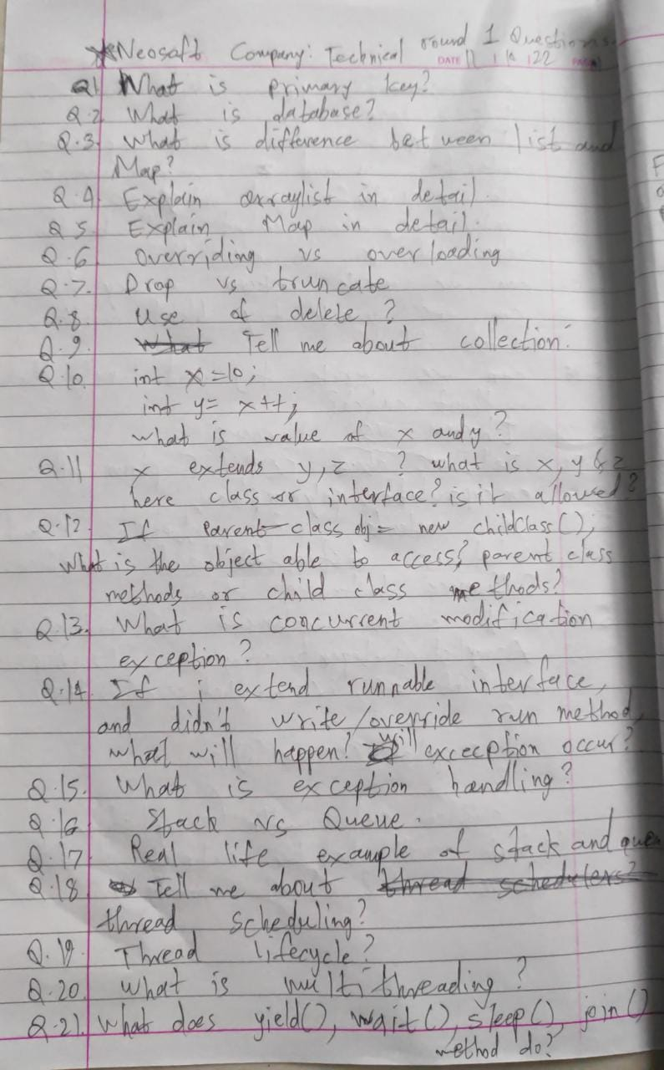

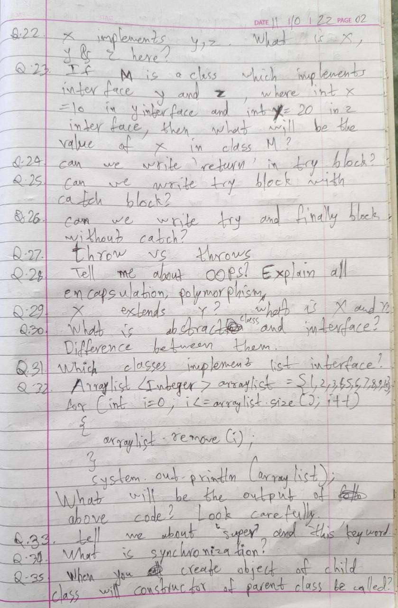

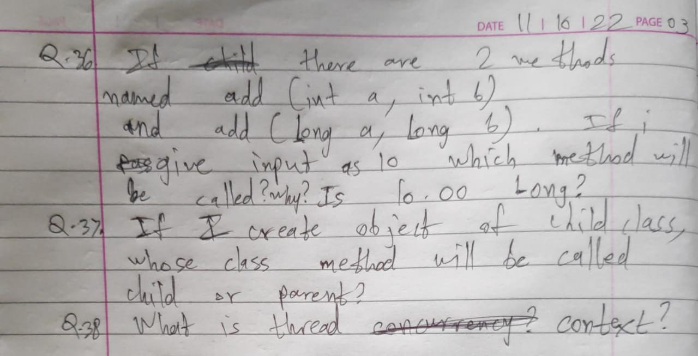

Neosoft

1.Introduce Yourself

2.How many technolog languages language you know.

3) Explain oops.

4) what is the difference between overloading and overriding and how to acheive it.

5/ what is multithreading.

6.How to create thread. What will be the sequence of thread excecution

7.

7.what is Synchronization.

8. yield, Join and wait methods.

9.Exception handling, why we need

try with finally is possible {1) Catch with finally is possible,

10.Explain String, String Builder and string Buffer

11.What is string constant pool.

12.Constructor chaing Questions.

13.we have two methods with same name , first method takes Integer and second take Long of wrapper class ,if we pass null to methods what will happen.

14.X extends Y,Z

15. X extends Y,implements Z

In these cases what will be X,Y,Z

Neosoft(Taken by Sameer Sir)

1.No intro, he introduced himself.

2.Core java: OOps concepts: Polymorphism, class , objects

3.Is java fully object oriented?What are primitive and non primitive datatypes? Differences and uses.

4.How to identify which method(of parent or child class) is being called during overriding?

5.Interface and class

6.Singleton class

7.Any questions for me?

TIA

1.Intro, Explain work flow of ur project, have you used any constarint for donor age in back end(I told we did that in react for drop down, he said good)

2.Project related: Your side in it, how did you connect front end to back end, how did you deploy on aws cloud? Database used? B.Tech project explanation.

3.React js virtual dom benefits

4.OOPS concepts: Explain overriding, overloading. How to identify both?

5.ArrayList and Array difference

6.Collection interface : Set, List, Map,Hashmap

7. How to remove duplicates from ArrayList? code in front of me

8. Sql based: Query to find employee with maximum salary, also to find second lowest salary, indexes

9. Exceptions: throw vs throws.Use of exceptions. try catch blocks

10. Modules learnt: What is web based java? What is web programming, software development methodologies?

11. Any questions for me?

Verifone

Oops concept

Why is java platform independent

Can we create top level class private

Encapsulation aur code uske upar

Diff btw abstract class and interface

Can interface extends multiple interfaces and class

Diamond problem

Restrictions of method overriding

Why dont we use static private final

Final v finally v finalize

Hashcode() and equals() method explain

Transient

Thread life cycle

Fibonacci series code

Hr:

Break and continue statement

Strength and weakness

1.introduce yourself

-.which object you created in autocad

2.why you choose IT

3.what challenges you faced in team management(college)

4.waterfall and agile

5.html form on VS code

6.lamda expression program of square

7.why we started to use oops?

8.program on string array sorting( without collection) no. Of characters ,even and odd

9.javascript unary functions

10. Javascript NAN

11.arraylist and vector

12.diff between primitive and ref type

13.thread pool

14.multi threaded example

15.Inheritance refernce object in child example given is right or wrong

16.in functional interface what is Consumer

17. What is alert in javascript

18.functions in javascript

19.post man (what is header) explain why we use post man

20.javascript how to display line by line ....

Managerial round:-

1. Http and https

2. Where you used http

3. Program on string splitting

4. Program on javascript to print random numbers

5.testing types of testing

6.diff between junit and integration testing

7.problem on selenium testing

**Flextrade**

Interview Round 1:

1) Tell me about yourself

2) Do you know C++?

3) Do you know Linux?

4) Tell me what is OOPS?

5) Do you know SQL?

6) Write an example for insert query in SQL

7) What is the difference between Delete, Drop and Truncate?

8) What is a stored procedure?

9) Tell me about inner join and outer join?

10) Complete the series:

i) 5, 7, 11, 13, ?, ?

ii) -1, 2, 7, 14, ?, ?

11) Do you know any Networking commands in Linux?

12) What does ping do?

13) What are telnet and ssh commands?

14) Command in Linux to check ip

15) Tell me the basic commands of Linux you know

16) Where is awk used? write a command to print the first three fields in the form of columns from a csv file

17) What is the use of sed?

18) What is the use of grep?

19) How do I find a file whose location I don't know but I have a string that file contains using grep?

20) What is the command to check RAM usage?

21) How to create a file in Linux (command)?

22) Do you know Java?

23) Tell me the difference between C++ and Java or why Java is better than C++?

Laminar Aviation Infotech

Laminar Aviation Infotech

1.Exam was on html,css and js.

one section was for coding and other three sections consisted of html,css,js questions theory+ snippets

Interview question.

First round..

What is inheritance?

What it html?

What is difference between class and id in css?

Tell me about ur project. Explain it in detail.

What is api?

Why did u use Reactjs?

What is React?

Features of React.

What is document.getelementby Id?

Second round

Tell me about yourself.

Why IT sector.

Family background.

What will you choose MNC or Small service based firm?

And some location, company project related questions.

Laminaar L1

1) briefly explain ur project

2) why u used react in front end

3) features of react

4) what is cls,cts,clr

5) what is delegates

6) why u used mysql for database

7) tell me react file structure explain each file.

8) wht is usestate and useeffect

10) wht is constructor chaining in c#

laminaar L2 ( technical+hr)

1) some logic based questions

2)how u create login, registration form

3)how validation is done in ur project

4) primary key , unique key

5) why should we hire u

6) family background

7) why 2 year gap between engineering and cdac

8) are u ready to relocate

laminaar aviation Technical round

1.why CDAC?

2.what is full stack ?

3.suppose we have u_Id and Uname userid is auto generated column then do

we need to add unique key constrain on username?

4.how data is send from front-end (JSON or XML)?

5.if we add reserved characters in json value will it accept?

6.how can I get single value from spring boot like(user/{id})

7.If i use that api in web browser will i get data?

if yes then where do you have used security? round-2 Managerial/HR

1.Introduce ur self (where are u from and family background)

2.Are you logical person ? when you applied logic recently?

3.what is software? give me the example which u have used?

4.What do you know about our company?

5.Are ready to relocate ?

Laminar Aviation Interview que:-

Frist round

1) introduce ur self?

2) suppose im a new person in IT and u have to explain me ur project?explan in detail?

3) explan all the service of ur project?

4) why u use react only?

6) what are packges and files react have?

6) why only class component instend of funcation component?

7) deffince between render and JSX?

8) differance between react state and propes?

9) why u use componenetdidmount?

10) why u dont use any other lib insted of axois?

10) which port no is use to connect it?

11) what is creat-app mean exactly?

12) why only springboot is use?

13) annotations for hibernate?

14) main class in spring?

15) tell in brif about opps and real life example?

16) diff between java and .net?

17) in .net what is funcation overloading?

18) static keyword nd static methode in .net?

19) differance between final,finalized, fanily?

20) write query on thrid highest salary?

21) which technology do u like most and why?

22) what if we put on .net section

Laminar Aviation Interview

Second round

1) what is ur favorite techology?

2) what unique knowdlege u have in react?

3) componet of .net?

4) cls nd cts diifeance?

5) why msil is used?

6) what is delegate?

7) what is coreFx?

8) why should we hire u?

9) did u ok to compromise with ur creativety?

after that sir speak in marathi with..

Kami Vision

1st round

Vinod Pathare

1) tell me about yourself

2)Tell me about your project

3)List down the api's you have used in your project

4)Tell about HTTP Methods

5)Difference Between post vs put

6)What is dependency injection

7)Autowired Annotation

8)How do you have connected database in project

9)tell about @RequestMapping and @RestController

10)tell about Singleton class

11)Open eclipse and Write Singelton class

12)WAP to find the 2nd smallest element from array...dont use arrays.sort()

13)what is time compelxity of Selection Sort

14)You are having 2 linked list of different length at what point they will intersect and form Y shape

15)without using head node 1 pointer is given and that node is to be deleted(ptr node) in singly linked list how will you do?

16)write a query to find 2nd max salary from table

17)3L 5L puzzle

18)do you have any question for me?

Q1.Expalain your Cdac project ?

Q2. Explain your role in your project(how much api and functionality you have written)?

Q. which data Structure you have implemented in your project?// my ans was list

// then he asked me abou linkedlist and how can we create it.

Q. how many days of experience of java do you have?

****Q. do you know working of hashmap?

Q. equals and hashcode contract?

Q. working of hashset?

Q. program Input: "i am saurabh"

output:"saurabh am i"

// // i made a mistake that there was white space before "saurabh". tried using trim method even //substring and even stringbuilder it didnt work bu lastly somehow it work but output

Q.do you know how to create custome ArrayList?//my ans was i dont know but i can create //linkedlist.

Q. explain imutabilty?

//i use why string are immutable as reference and gave him ans.

Q. explain Enum? custome datatypes in enum?

*****Q. does enum have constructor?explain how to write custome methods in enum?

// i wasent able to ans custome method ans.

Q. Explain serializable?(then goes deep)

Q. where we use serializable interface?specifcally in your project?

****Q. Explain MultiThreading( did you implement it)?//he kept asking me about how to create threads and diff ways .// he wanted to know more about that.

//my ans was no i did not implement it in our project. I explained to him about session object creation by session factory for two diff clint but he insisted upon multi Threading, then he asked me about the Thread executor framework?// my ans was i don't know.

Q.tell me any Url that you have written?

// ans: "/doctor/bookAppointment/4"

****Q. http methods?different http methods?

// ans i don't know

Q. rest protocol?

diff rest method?

Q. custom exception? how to create it ? did you written in your project?

// my ans was yes i have handled it globally.explain him about diff annotation that used in global exception handling.

Q. for creation of id which annotation is used?

Q. he asked me about one or more annotations which i don't remember.

Q. Explain the primary key?

Q. explain the difference between abstract class and interface.

Q. do interfaces have concrete methods?

Q. Do interfaces allow multiple inheritance?

Q. static initializer block?

Q. if i needed to sort Arraylist of employee then how can i do that?

// my ans was comparable and comparator interface.

// how can we implement it.

Q. How can I implement a comparator ? different ways// ans. by implementing interface,Anonymous class, or by lambda function.

*****Q. Suppose there are 3 tables User(userid,userName),doctor(doctorid,doctorname),appointment(userid,doctorid) i.e. pivote table showing many to many relationship.

expected output: patirnt name with doctor name.

Kami Vision

Interview question:

1. Introduce yourself

2. Project related question

3. Which technology you are good at

4. Regarding collection framework in java(hashmap and hashtable)

5. How to access both key and value of hashmap

6.Write a code for above

7. Write a program to get second highest from array without sorting the array

8. Linux related question

9 Linux command to get process id

10 Linux command to get disk space

11 difference between df and du command

12 command to list out all running process

13 What is normalization in DBMS

14 Some basic question on azure because of my certification

15 Then suppose we have database on any cloud the what command is used on terminal to connect to that database

16 Scenario based questions:

Suppose all the words from newspaper are stored in a file and you have to find the string which is occuring maximum number of time, how would you do it

There was no hr round after this

Only technical round

Integrate

(Vishal Patil)

1) Give brief description about, what modules did you learnt during cdac course

2)Tell me about your project

3)Authentication used in your project

4)Tell me the flow of Authentication

5)In database column I have 100 records ,marked with sequence which is pk, if I remove last 5 entries from it, and added one more entry what will be it's pk

6)i gave ans as 101, so he asked how can you avoid it, so it can start with 96?

7)Assume a scenario where you have to save a user to database, How would you approach to above scenario means tell me flow from frontend to backend

8)what is .net

9)can you decode jwt token

10) jwt consist of? - (header,payload, verify signature)

11)from VishalPatil String find out duplicate chars kadhun dakhav

12)later he changed scenario find out the repeating frequency of these chars also

13)also asked about pk and fk

i got disconnected in the last while writing code in the last code was complete almost, then reconnected back and then he said ok our hr team will get back to you

Introduce yourself

Explain your project

How did u store ur password

Architecture that spring boot follows

What is aop

Interface and abstract class diff

And when to use which

What Is polymorphism

What is method overload and method overriding

What data structures u have use

DFS function for graph

Code

About java version11

Collection framework stream 3 method

About filter map reduce Hashmap vs hashtable

Asked about Hackenrank questions

Introduction including full detail b tech dac proj n all

Technical strength also

Write java prog to return second largest number of an array

About java version

Abstract classes

Composition vs inheritance

Overloading vs riding

Interface

Try with resource

What to do if want that no one can override a method

Pass by value n pass by ref

Concurrent hashmap

What kind of design pattern u have used in your proj

Flow of a request n resp in spring

company:-Integrate

First Round

1)Intro

2)Project Explain

3)Annotation used in Project

4)What is Autowired

5)which Database Used

6)Explain Database Structure and how normalazation implemented in it.

7)write controller and repository for postMapping

8)write controller and repository for GetMapping

9)write controller and repository for GetMapping by Id

10)What is pathvariable

11)what is hooks

12)explain useEffect

13)what is Axios

14)how to connect front end to backend

15)what is reponse Header and request Header

16)How Many Ways you send data from postman(Json,Html)

17)Do you no about Reponse Contain type

18)Reverse String Code

19)Any Que

Second Round

1)Intro

2)Explain Project

3)Write Rest Api

4)Count And Duplicate Char from String

5)Reverse String Using C#

6)Garbage Collection in C#

7)Which Datatype Used to Store 100 Digit Number

8)Write Code for Addition of two 100 digit number

9)polymorphism

10)method overloading with real Example

11)Inheritance with real Example

12)Static method and Static Variable

13)Do u know About .net core

14)Diff. Between .net core and .net Framework

15)Any Que

Third Round

1)Intro

2)Project explain

3)Explain Database of your Project

4)are U ready to reloacate

5)are you comfortable with .net and react

6)they give me information about company

7)Any Que

Fourth Round(HR-Round)

1)intro

2)if you have any query then ask

End of rounds

Knight Fintech

Interview questions

------------------------------------

Final project in detail

How session management is done

What is JWT

How exceptional handling is done in backend

In-depth project questions

-OOPS concepts

With programming example

-Collection

-Array and arraylist

-Exceptional handling

-Interface and abstract class

-What is static class and its use

Database:-

-Unique key

-Composite key

-Stored procedure

-Types of join

-Diffrence between inner join and outer join

-mostly Scenario based questions on above topics

And interviewer was preferring short ans

Introduce Yourself?

Session management and cookie management?

Project explanation.

What is http headers?

Difference between get and put method and how access it?

How authentication done in your project?

How password encryption done in your project?

How connect front end and backend?

How user add new data to database,which layer you used for that?

What is code in your service layer?

What is Entity?

SQL query for find the count of vehicle on the basis of fuel ?

what is aggrigate function?

What is view?

What is encapsulation?

Poymorphism?Types?

Overloading and overriding?

Interface?

One snippet and asked output

One puzzle: How to calculate the fuel consuption of new delhi?

Company name- KFintech

Oops concept in detail

Inheritance with types + coding

Polymorphism

Types in polymorphism and their difference

Encapsulation

Abstract keyword

Abstraction

Interface

Difference between them

Static keyword

Difference between == and ===

Exception handling

Try catch

Conditional based questions

Array

ArrayList

constructor, types, syntax

Some coding on constructor

Data abstraction

Types of exception handling with example

How many checked exception are there

Array related conditional based question with small code

What is package

Types of packages

what is DDL and commands

Normalization

SQL queries

Joins, types

Extension method

How to convert string into int?

Project

Codes

1. All types of inheritance code

2. Fibonacci series using recursion

3. Swapping without 3rd variable

4. Print random number

5. Prime number

Knight fintech Banglore Region

1. Situation based question

2. Project flow

3. MySQL ddl dml command

4. Question on view

5. Session Management

6. Reader & Adapter Class

7. inheritance

8. Overloading / Overriding

9. What is http, stateless

10. RestApi

11. Tokenization (JWT)

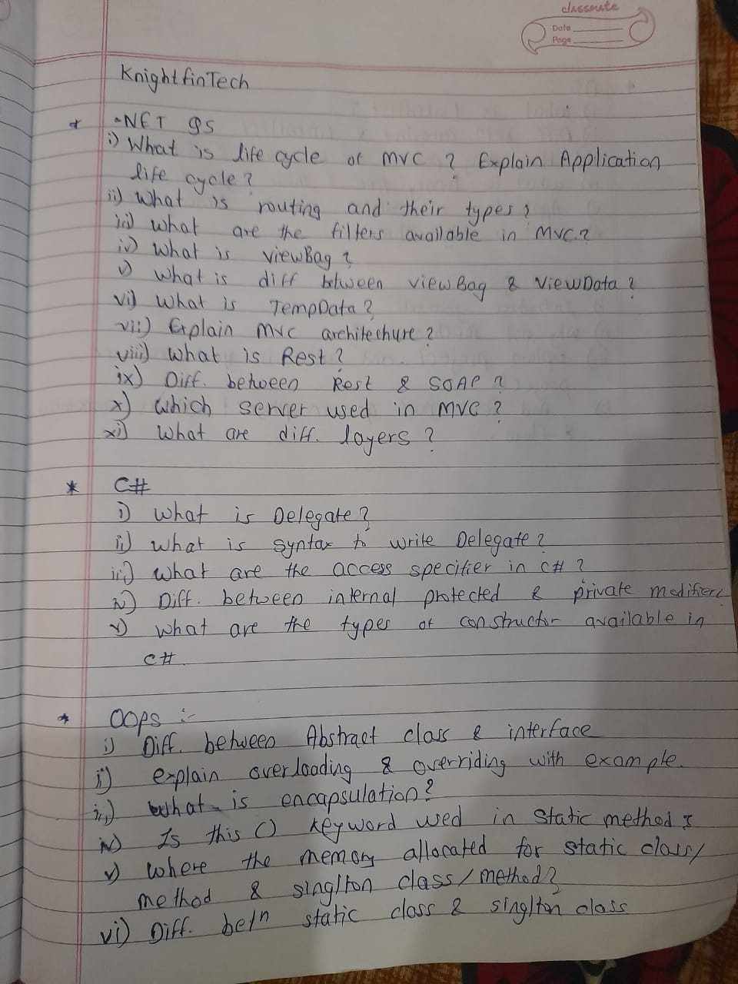

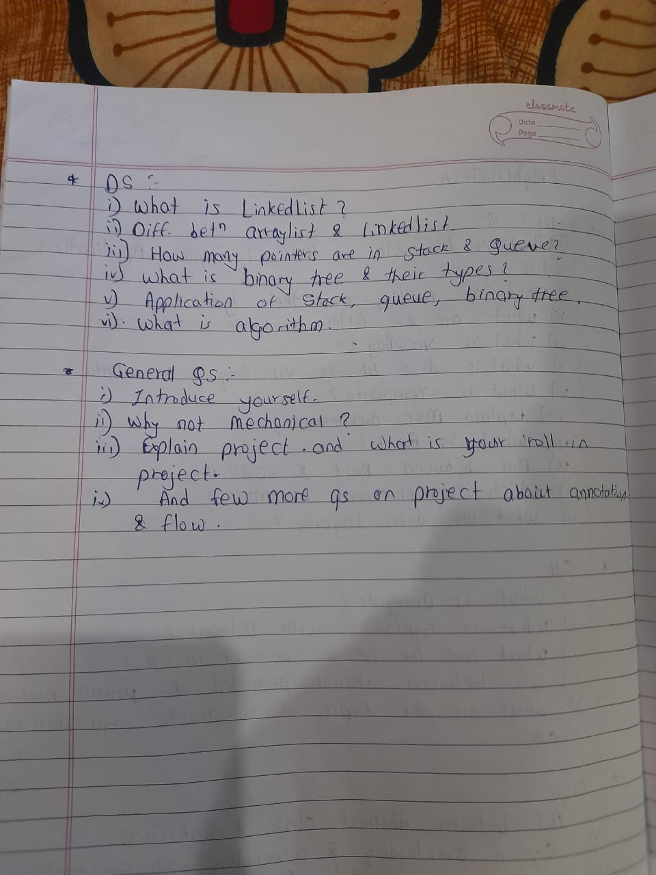

Kfintech (8 LPA/Mumbai,Hyderabad,Bhubaneswar,Ahmedabad/Hybrid[WFO+WFH]) interview round by Prayag Monsara :

1. Introduce yourself

2. Tell me about any 2 best projects you worked on which are applicable for this job.

3. How many members were there in your team? What was your part?

4. Did you implement it in docker?

5. So how did this benefit the clinic?(Project is going to be used by a clinic hence sir asked how it will help the clinic)

6. What was the system/process used previously in the clinic?

7. Why do you used Spring boot?

8. Diff between spring and spring boot

9. Why do we use JPA in spring?

10. How did you send data from java to database? Did you use JDBC? and frontend to java?

11. Which dependencies did you used in Pom.xml?

12. How did you connect your backend to database? What methods did you use?

13. Does spring give dependencies automatically?

14. Have you created any project on react? Have you studied react?

15. What is this second project mentioned in you project on GIS?->BE project? What was your role in it?

16. What is react ?why do we use it?

17. Can browser read JSX directly? or do we need to convert it into anything?

18. Can browser read HTML and CSS directly?

19. What is diff between JSX and html?

20. Why do we use MySQL server?

21. Which language is MySQL written in?

22. Write a query to insert foreign key.

23. What is difference between Database and Table?

24. How to swap numbers without storing them in another temp variable.(just tell approach verbally)

25. How much will you rate yourself in Data structure on a scale of 10?

26. Which language are strong with?

27. Find median of two sorted arrays. Tell me approach first then we will see if we want to go into implementation.

(Do you know what is median? Do you remember mean, mode, median?)

28. What is time complexity and space complexity of your approach?

29. What is n in time complexity? There are 2 arrays here so will the complexity be m+n?

30. If we want to reduce the time complexity and not use another third array to store new array, what approach can we take?

31. Do you have any questions for me?

Kfintech interview questions

Introduce urself

Some scenario base questions on project

What is interface

What is diff between abstract class and interface

Why we need interface

Write a program and show an example of interface

All above had to do in c#

Doubly linear linklist delete operation code

A scenario given and a table and asked to write a self join query

What is Asp .net

Ado.net

.net core

Configurations

What is bundled configuration

Who is responsible for memory management in .net

Any questions for me

Sapiens

Tell technologies you learn in C Dac

Project Explanation

Are you willing to work on .net and C#

Program Structure of C# program

Polymorphism Example Method Overloading & Overriding

Method Overloading & Overriding is Compile time or Runtime

String Reverse

Right Join on Two tables

What are the primary key and foreign key can we have multiple primary keys

0.just asking how are you doing?How was your day? Is .net easy compared to java?

Why are your marks less in .net?You dont like it?Are you comfortable with C#?Will you be willing to work on it?

1. OOPS concepts:(explain all 4 pillars with real life examples in detail)

2. write code of inheritance in c#

3.Write a code to reverse string in sentence word by word:

string input: I love my country

string output: I evol ym yrtnuoc

4. Access modifiers in C#?All types where do we use?

5.Where do we use Internal access modifier?

6.If i want to prevent access to any external assembly which modifier to use?

7.If i want to give access to only my current assembly which modifier to use?(i will decide later if inheritance is to be used or not)

7.If i want to give access to only external assembly which modifier to use?

8.If i want to prevent inheritance in my current assembly,which modifier to use?

9.Have you heard of protected internal modifier?

10.Boxing and unboxing

11.Types of indexes

12. I i have 5 tables containing info of employees name,salary,education,personal info and i want to show it what will you use?

Other than Inner Join can we use anything else?

13.What are Views?

14.Diff between normal table and view?

15.difference between delete and truncate

16.Which front end technologies have you worked on?

17.Have you worked on Javascript?

18.How to merge 2 columns in HTML?

19.If i have 2 jars one of 5 litre and 1 of 3 litre. How will you get 4 litres of water?

20.Any questions for me?

Sapiens interview round 2(Manager)Vishan Singh:

1.What do you know about c#?What have you learned till now?

2.Tell me about polymorphism.

3.Types of polymorphism.

4.Difference between abstract class and interface.

5.Boxing and unboxing.

6.What are delegates and events?

7.Types of delegates.

8.Difference between Java and C#?

9.What are generics?What are generic Collection?

10.Do you know about Reflections.

11.Why are you are having less marks in .Net and Web java?

12.Why shift from Civil to IT?

13.Any questions for me?

Sapiens interview round 3(HR)Manoj PV:

1.Tell me about your background?(Siblings,current location,parents,any gap)

2.Do you plan to go for higher education?

3.Tell me about your project.Project flow.

4.Tell me about your role in the project(CDAC & BE).

5.Why shift from Civil to IT?

6.Are you ready to shift to banglore?

7.Tell me about yor BE project.

8.What is your short term goal?

9.Where do you see yourself in 5 years?

10.What are your strengths?

11.What is your weakness?

12.Do you have any relative staying in Banglore?

13.Any questions for me?

Sapiens(6.5LPA/Banglore/WFO) interview round 1 by Nitin Katte:

0.just asking how are you doing?How was your day? Is .net easy compared to java?

Why are your marks less in .net?You dont like it?Are you comfortable with C#?Will you be willing to work on it?

1. OOPS concepts:(explain all 4 pillars with real life examples in detail)

2. write code of inheritance in c#

3.Write a code to reverse string in sentence word by word:

string input: I love my country

string output: I evol ym yrtnuoc

4. Access modifiers in C#?All types where do we use?

5.Where do we use Internal access modifier?

6.If i want to prevent access to any external assembly which modifier to use?

7.If i want to give access to only my current assembly which modifier to use?(i will decide later if inheritance is to be used or not)

7.If i want to give access to only external assembly which modifier to use?

8.If i want to prevent inheritance in my current assembly,which modifier to use?

9.Have you heard of protected internal modifier?

10.Boxing and unboxing

11.Types of indexes

12. I i have 5 tables containing info of employees name,salary,education,personal info and i want to show it what will you use?

Other than Inner Join can we use anything else?

13.What are Views?

14.Diff between normal table and view?

15.difference between delete and truncate

16.Which front end technologies have you worked on?

17.Have you worked on Javascript?

18.How to merge 2 columns in HTML?

19.If i have 2 jars one of 5 litre and 1 of 3 litre. How will you get 4 litres of water?

20.Any questions for me?

Sapiens interview round 2(Manager)Vishan Singh:

1.What do you know about c#?What have you learned till now?

2.Tell me about polymorphism.

3.Types of polymorphism.

4.Difference between abstract class and interface.

5.Boxing and unboxing.

6.What are delegates and events?

7.Types of delegates.

8.Difference between Java and C#?

9.What are generics?What are generic Collection?

10.Do you know about Reflections.

11.Why are you are having less marks in .Net and Web java?

12.Why shift from Civil to IT?

13.Any questions for me?

Sapiens :

1)Introduce yourself

2)What is OOP?

3)Is java is fully OOP or not?

4)code for even odd number?

5)4 snippets outputs?

6)what is wrapper class?

7)what is inheritance?

8)public static void main( string [ ] args) - Explain meaning of that statement.

9)What is abstract class?

10)What is type of constructor & Explain with example.

11)Explain your project?

12)How inheritance work in your project class?

13)If main method is not static then it will run or it will give error?

14)Difference queries on database.

Sapiens(6.5LPA/Banglore/WFO) interview round 1 by Nitin Katte:

Student name: Mayur Chaudhary_CDAC_TVM_March-2022_DAC

0.just asking how are you doing?How was your day? Is .net easy compared to java?

Why are your marks less in .net?You dont like it?Are you comfortable with C#?Will you be willing to work on it?

1. OOPS concepts:(explain all 4 pillars with real life examples in detail)

2. write code of inheritance in c#

3.Write a code to reverse string in sentence word by word:

string input: I love my country

string output: I evol ym yrtnuoc

4. Access modifiers in C#?All types where do we use?

5.Where do we use Internal access modifier?

6.If i want to prevent access to any external assembly which modifier to use?

7.If i want to give access to only my current assembly which modifier to use?(i will decide later if inheritance is to be used or not)

7.If i want to give access to only external assembly which modifier to use?

8.If i want to prevent inheritance in my current assembly,which modifier to use?

9.Have you heard of protected internal modifier?

10.Boxing and unboxing

11.Types of indexes

12. I i have 5 tables containing info of employees name,salary,education,personal info and i want to show it what will you use?

Other than Inner Join can we use anything else?

13.What are Views?

14.Diff between normal table and view?

15.difference between delete and truncate

16.Which front end technologies have you worked on?

17.Have you worked on Javascript?

18.How to merge 2 columns in HTML?

19.If i have 2 jars one of 5 litre and 1 of 3 litre. How will you get 4 litres of water?

20.Any questions for me?

Sapiens interview round 2(Manager)Vishan Singh:

1.What do you know about c#?What have you learned till now?

2.Tell me about polymorphism.

3.Types of polymorphism.

4.Difference between abstract class and interface.

5.Boxing and unboxing.

6.What are delegates and events?

7.Types of delegates.

8.Difference between Java and C#?

9.What are generics?What are generic Collection?

10.Do you know about Reflections.

11.Why are you are having less marks in .Net and Web java?

12.Why shift from Civil to IT?

13.Any questions for me?

Sapiens Interview Question

1.Introduce Urself and explain ur cdac project

2.Explain Oops concept

3.Explain Overloading and Overriding

4.Write a code on overloading

5.Write code on Reverse String word by word

Input :- I love my country

Output :- l evol ym yrtnuoc

6.Write a code on count character sequentially

I/p :- aaabbbddcaa

o/p :- a3b3d2c1a2

7.What is data structure?

8.What is Sql?

9.explain DDL,DML,TCL

10.explain drop,truncate and delete.

11.What is C#?

12.Which Access specifier present in C#?

13.difference between protected and internal

14.Do u know about solid property?

15.How can we merge two column in html?

16.How can we merge two row in html?

Ref :- First Name Sub. Marks

Sub-1. 23

Chetana. Sub-2. 22

Sub-3. 23

Write a code for it only for merging.

17. Do u have any questions?

Tell technologies you learn in C Dac

Project Explanation

Are you willing to work on .net and C#

Program Structure of C# program

Polymorphism Example Method Overloading & Overriding

Method Overloading & Overriding is Compile time or Runtime

String Reverse

Right Join on Two tables

What are the primary key and foreign key can we have multiple primary keys

self introduction?

oops concepts?

Give rating to you in oops concept?

Write syntax for inheritance?

what is searching array types?

write the binary search algorithm?

Ask any question?

Sapians

1. Technologies learn in course and Project in brief.

2. Database use to store the data in project system.

3. Frontend to backend project connection flow.

4. User interface part related to project.

5. Explain C# page interface -- what is Namespace, class, assembly, different imports in any programs.

6. OOps concepts inheritance with code implementation.

7. How to create object and access properties of other class.

8. What is interface and abstarct class difference and implement it with code.

9. Coding logic -- string reverse, string characters count.

10. Sql info, database intro, dbms types why we use db, functions and procedures.

11. execute query -- join two tables and show similar named id and names.

12. types of joins.

13. Questions for me.

Questions -

1.Introduce yourself.

2.Explain project .

3.write a query of peticular skill search from job seeker in your portal (project releted).

4.What is C# , why do we use C# ?

5.What are the C# access modifiers ?

6.What is CLR ?

7. What are generics in .NET ?

8.What are delegates and types of delegates ?

9.What is an object pool in .NET ?

10.What is difference between java and c# ?

11.Explain OOPS concepts with examples ?

12.What are the types of classes in java ?

13.what is singleton class ?

14.What is inheritance ,write down the code of inheritance ?

15. Write down the code of Reverse String word by word

Input :- I love my country

Expected result:- I evol ym yrtnuoc code

Bajaj Market

1. What is serlization

2. What is hql in hibernate

3. Write two code

For string reverse

For array multiplication

4. What is encapsulation

5. What is abstraction

6. Introduction

7. Project

8.String builder vs string

Bajaj-Market

1)intro

2)write rest api

3)write service and service Impl

4)how many sorting method are available

5)Implement one of them

6)time complexity of bubble sort

7)write program to remove duplicate element from array

8)Any Question

Bajaj Market - Interview

1.Intro Yourself

2.About Project - Tools,Technology,backend

3.What is abstraction?

4.What is singletone Web Application

5.Spirng boot - mapping

6.ORM in spring boot

7.They said open notepad and write a logic 1.input array = {2,4,1,5}; then output is = {20,10,40,8 2.REverse a string

Bajaj Market interview :-

1) Introduce yourself

2) what is string pool? Why it is used ?

3) Do u know hashmap? What is load factor. Intial capacity of hasmap? I said 16 . After 16 what happens. I said there is one formula using that we calculate laod factor with intial default capacity 16.

4) explain static binding and dynamic binding in polymorphism.

5) one scenario based question.. That i have to sort objects.

6) write a code for Fibonacci.

7) explain comparable and comparator

8) tell me about your project.

9) Do you know restful web services?

10) what are the http methods that are used in rest api?

Bajaj Market:

oop in java: all pillars

what is abstract class

difference between abstract class and interface

why we use interface

do you know about collections

in notepad write complete code for List operations

if need to print just even numbers from the above list

Do you have any self project made till date?

Bajaj Markets

1.Types of class loaders in Java

2. Difference in Concurrent Hashmap and Hashmap

3. Tree Traversals

Which is more efficient.

4. Implement run time polymorphism

5.String reversal code

6. Palindrome code

7.OOPs pillars with examples.

8. Difference in interface and abstract class . When to use what.

9. What is Rest .

Methods in rest.

10. Write a REST api for contact number and first name.

11. @SpringBootApplication , @RestController Usage

Then branch specific questions

1. What is handshaking in networking.

2. What is Modulation .

3. Types of modulation

4. How is depth of sea measured ?

5. Two wave with 5Ghz and 2.5Ghz of frequency . Which will travel farther .

6. Working of Bluetooth.

Bajaj Finserv

Coding test on HackerEarth,

total 13 questions - 11 - Tech MCQ and 2 Coding Questions

Second Round Technical Interview - for 35 min -- Core Java, Advance Java and SQL

1. Introduce Yourself,

2. Explain Final Year Cdac Project As I have implemeted payment gateway so he was more interested in it and asked how it works,

3. What is web redirection

4. Flow of request --- response in Project Starting from Front end form till data base and,

Explained this with all the small details and also in terms of code

5. What is collections and its hierarchy

6. What is generics and why we should use generics

7. Exception Hierarchy,

8. Can we throw errors? If Yes, can we handle erros, and what will happen when we throw errors

9. What is Static Methods and Variables

10. Can we override static methods, and if we override static methods will it be compile time exception or RTE?

11 . What is difference between Encode and Encryption

12. What is JWT, and REST API

13.create table by using below fields

id, name, sal, doj, deptId

14. Queries asked

select deptno,sum(sal) from employee group by deptno;

select deptno,sum(sal) from employee group by deptno having sum(sal) > 5000;

15. Collection Scenario

List<Employee> list=new ArrayList<>();

Employee emp=new Employee(10,"Prasad",2500);

list.add(emp);

emp.setName("Abhi"); // if we print list how it will appear

emp=new Employee(11,"Sumeet",400); // if we print list how it will get printed after this line

Bajaj Finserv

introduction

Java 17 features

Java 8 features

What is Stream API

Thread life cycle

Working of HashSet

Can we override static method ?

and 2 3 questions more.

Company:--Bajaj Finserve (8.2 LPA)

round 1 -- write API and check with postman and post details on given link

======

round 2 -- technical mcq 11 questions(medium level) + 2 coding question

====== (1st Ques done with all cases for me...... 2nd Ques not run only compilation done completey)

round 3 -- technical

=================

-- introduce yourself briefly

-- why you are shiftinf from mechanical to IT( required very solid proof....he will ask this one question to min till 5 min.)

-- what factors because of which you came here....money??? or something else

(if you are not from cs / it then prepare this question very seriously.....this question affects your interview most ....i think)

--which version of react you used in your project???

--explain your project??? which technology??? why spring boot??

-- the use of spring boot i tell.....he ask me that ....most of these are also given by node ,then why you not use node.js???

-- give senario

4 technologies are there......on which thing you select you technology for your projecyt???

(mostly I tell spring boot.........but he said if company req. node then what you do.........because u r prefarable in spring......how will you handle that situaion????)

--give 3 main aspect to select any technology which is 100% suitable for project ani company benifits

(Above 2-3 question are only for your confidance checking..and situation handling...........he not required how i good in my tech skill)

-- code==

write one function contains string as argument.........check it is palindrome or not........reture only true or false in output

(He ask me to share screen and write code in notepad ..........need to write full program ....not only logic...........not ask to run the program)

round 4 - HR(only 2 min ....on mobile call)

=======

--how is your interview ???

--is pune location prefarable???(pune and banglore given in job discription??

--any question???

NetSPI

Prasad Gawade

Pattern

1 test -- Reliscore platform --- there will be 6/7 different sections and 1 codning question,

First Round Tech interview

1. Introduction and Project Explanation and as I have deployed my project on docker I have shared link in chatbox

2. What is HTTP, and What is REST API,

3. How you managed session in backend (In Rest Web service we do not manage session in the backend )

4. WHat is JWT and Web Security

5. Write a code to to show right hand side view of the binary tree in IDE

6. What is difference between Spring and Spring Boot

7. Why You used react js

8. Which external libraries you have used in project,

9. Have you used any external APIs in project in front end or backend.

Second Round -- (Prepare all concetps related to JWT security in depth)

1. Introduction, Why You left Old Organisation ,

2. What was your project

3. Explain in detail JWT Working, (You will be able answer all questions only if you have done everything by yourself)

4. Concetps regarding process and multithreading

5. What is process and thread

5. Java -jar what will this command do will it create process or thread

6. What are stored procedures and views

7. Given one scenario asked me to discuss design

book can be issued to many users

user can have many books

one book belongs to one library

one book have many authors

one author can write many books

8. Explain the working of garbage collections

9. What is memory leak in java, what can you do to minimize it.

*** NetSPI ***

2 Codes:

1. Given a string, you need to sort it by the frequency of alphabets in it. Sample i/p: tree | sample o/p: eert

2. Merge two sorted arrays and sort them while merging itself.

Q1.What is internal working of HashMap?

Q2.What is internal working of HashSet?

How does it detect duplicate objects?

What if I override the hashcode function and return 0 for every object? Suppose, If I created a class of employee and want the insertion based on employeename, what would happen if the employeename was different and hashcode returned 0 for every employeename? would it identify the objects as duplicate or different?

Q3.What are checked and unchecked exceptions?

Q4.In multithreading, if my machine is single core, and I wrote a code to create 5 threads, will it create 5 threads?

What would happen if the machine was of 2 cores?

Q5.Is java fully object oriented? What makes it incompletely object oriented?

Q6.How the diamond inheritance issue is handled by java?

Q7.How can I implement the methods if 2 interfaces having same method?

Q8.What is your favourite feature of Java 8?

--Frontend / JavaScript:

Q1. What are higher order functions?

Q2. Difference between normal function and arrow functions?

Q3.Difference between forEach and map functions?

Q4.o/p of i) 5+'3' in java and javascript?

ii) 5-'3' ?

iii) 5-'-3'?

Q5.ES6 features?

There were few more questions. unable to recall now

MorningStar

Morning Star L1

1) spring bean life cycle

2) 5 scope of spring bean

2) event handling in spring

3) tell me about promises

4) wht is normalization

5) wht is trigger

6) wht is function

7) what is procedure

9) write a query to display 3rd highest salary

10) write a query to display

duplicate name

11) what is garbage collection

12) tell me about solid principal..

13) delete, truncate,drop difference

14) briefly tell me about ur project

introduction

cdac journey

B.E. project in details how it work

why IT

about cdac project

rate yourself in java

oops concept with detail with real time example

how we achieve abstraction

how we achieve encapsulation

what is runtime polymorphism

why we call compiletime polymorphism

why we call runtime polymorphism

diff bet overloading and overriding

what is multithreading

diff bet runnable and thread

when to user runnable and when thread

what is interface

how we achieve multiple inheritance through interface

(in we have two interface having 4 abstract method each then how multiple inheritance works)

what is exception handling

when to use throw and throws

query to find marks greater than 40 (join query)

what are the joins

how string memory allocation is happening

String a= "Prashant";

String b= "Abhi";

String c= "Prashant";

why string immutable

any questions;

Round1

1. Introduction

2. Relocation ready to shift Mumbai

3. Password encryption decryption in project. Other options

4. Project in detail

5. Types of constructor

6 CTS and CLS

7 Assembly

8 managed code and unmanaged code.

9 Normalization upto 2 NF

10 mvc

11 function vs stored procedure

12 class and object

---------------------------------------------------------

Round 2

1. Introduce yourself.

2 . Ready to learn angular

3. Project in detail.

4. How you will implement polymorphism in project.

5. Vivew and indexes

6. Coding problem of reverse string

I/p "I am student of cdac"

O/p "cdac of student am I"

7. Tell me two strength and two weakness.

8. How will you overcome your weakness.

9 . How will you do self learning.

10. Any questions for me.

Hr

1. Introduce yourself

2. Why mechanical to it

3. Any internship after graduation

4. If you have lot of time and money what you will do.

5. Tell something about morning star

6. Other discussion like joining date and role

Be confident through entire process. If you stuck at anypoint ask for hints. Be honest. Try to explain code while writin

MorningStar

Candidate name -> Sanket Hiremath

Batch -> March to Sept 2022

First of all I would like to suggest that please be Honest while answering, If you don't know the answer, don't bluff. Tell them I don't know.

Have some energy & grace while answering the questions.

Morning Star Interview 1st Round :-

1. Introduce yourself

2. Explain Data Flow from Front End to the Back End.

3. How did you do validations in your project.

4. What is json?

5. Explain OOPS Concepts with Real Life Example.

6. If I want to print my name 100 time, How can I do it in java.

7. What are different ways of Creating object in java?

8. What REST api methods?

9. Explain the types of Spring Beans.

10. Why you used Spring Boot for your project?

11. What are the different features of Spring Boot?

12. What will you do if Exception happens in the for loop? (Exception Handling & Throws Keyword)

13. Can we write Try block without catch block??

14. When we handle the exception? What will you Catch first, USER DEFINED EXCEPTION OR EXCEPTION??

15. What is Hybernate?

16. What is the advantage of using hybernate?

17. Do you know anything about spider? (Then she explained me what is spider)

18. Why you changed your career from Mechanical to Software?

19. Do you have any questions for me?

2nd Interview Round :-

1. Introduce yourself

2. explain your project, your role and responsibilities?

3. Why did your teammates choose you as a Project Leader?

4. Can you justify your leadership qualities?

3. What are the things that you found interesting in Java? (I told him OOPS and Exception Handling)

4. How did you Handled Exceptions in your project?

5. How did you implement OOPS concepts in your project?

6. If I select you to work on a project, what will be your approach & in how many days you will start to contribute in project?

7. While you were working in your previous company? what things you found interesting?(I was working in Mechanical Industry Earlier)

8. Do you think that your project will completely replace XLS sheets & Word Documents completely?

9. As a leader, If your team fails what will you do?

10. Do you love solving problems?

11. What is approach to solve a problem?

13. What will be your approach to learn any new technology? - (They want to check whether you have self learning ability)

14. Why you changed your career from Mechanical to Software?

15. You are from solapur, so are you willing to relocate?

16. Do you have any questions for me? (I asked him two question) - please note that you ask meaningful questions.

HR Round :-

1. Tell me about yourself?

2. Why you changed your career from Mechanical to Software?

3. Why you want to Join MorningStar?

4. Are you willing to relocate?

5. Are you willing to work in shifts?

6. Explain me your Engineering Project?

Morningstar technical interview

1. Tell me about yourself

2. Which languages are you most comfortable with?

3.What is difference between stack and heap?

4.Can u overload main function?

5. What is string pool?

6. How to use hashmap to add data?

7. What will happen if we use throws IOException on parent class and throws Exception on child class

8.Why wait and notify is declared in Object class instead of Thread?

9. Puzzles (2 questions )

HeraldLogic

Herald logic Round-1

1. write a program which return true and false

arr[]={1,2,3,5}

if addition of two array elements are equal to target element

target = 8

o/p = true

2.what is complexity of program ,can you do it in O(n)

3.explain collection hierarchy

4.what is diff between LinkedHashSet vs HashSet

5.what is use of Iterator

5.If we have foreach loop then why there is need of Iterator

6.explain exception handling (checked vs unchecked)

7.how we handle checked and unchecked exception

8.trow vs throws

9. explain project? what was the difficult part in it and why ?

what was the complexity of that part?(I said login validation)?

10.Do you used encryption to save password how it is stored in database?

10.Why CDAC?

Motilal Oswal

FS interview questions:-

1) introduce yourself?

2)what is abstraction?

3) what is static binding?

4) what are features of reactjs?

5) virtual functions/methods?

6) function overloading

7) what is polymorphisms?

8) if you are a fresher what were you doing one year?

9) 18=30% of x ? Solve orally

10) 4 by 4 inchs a empty rectangular wall is there and 4 by 4 tile is there then how many tiles are required for that wall to fit in ?

11) what is string class ?

12) what is difference between string buffer and string builder ?

13) what is primary key?can primary key have null value or not?

14) what are constraints used and name some of them ?

Verifone

1)project

2)comparator vs comparable

Where we use both of it

3)Arraylist vs Vector

4) serialisation and deserilisation

5)opps in java

6)why we used @transactional at service layer

7)IOC and dependency injection

8)tell me annotations used in ur project

9)get vs load

10)node.js vs web application

11)collection hierarchy

12)Crud operations

13)View in database

14)post and put

15)RestController vs Controller

Verifone

All about project

1)N-tier architecture of project

2)ATM machine scenario based question: what all conditions will you test

Which database used for project

3)How to create database and table

4)Default port of MySQL

5)Fetch data from table of specific date

6)Can we declare interface as final

7)Can we write abstract method without abstract class

8)Why do we create packages

9)Explain polymorphism

10)2-3 code snippets based on expection handling

11)Swap 2 numbers with and without using third variable

12)Write a program to count no of particular word in string using hashmap

13)Significance of local inner class

14)Why object is immutable in java

15)Ways to write string

Significance of final class

16)Agile methodology

17)Garbage collection in java

18)How to make write only class in java

Verifone

Introduce yourself

Project in BE and CDAC

1) diff bet http and HTTPS

2) How will develop chat application

3) What is jar file

4) What is XML file

5) collection framework que

6) algorithm for finding LCM of 2 numbers

7) How to iterate hashmap

8) What is class loader and class path

9) query to delete table

10) why main method is static

11) JVM architecture

12) How java is platform independent

Verifone

Student name : Suyash

Round 1: Apti 40 questions 20 min

Round 2: 1 code medium level and 5 mcq(mixed ds, os, network)

Round 3:

Techical View round 1

Introduction, asked which lang u r comfortable in i answered JAVA

Immideatly asked to write code to remove duplicates from string

while i was writing he was also asking questions on what i was writing,

i was using hashmap in logic he asked what is map types of map diff btwwn hashmap treemap all were answered. then he started with base class object access modifiers diff btwwn java n c or cpp then asked about abstract class interface and gave me diff secenarios , asked for reallife example.then asked about final keyword multithreading all things how to create threads thread life cycles grabage collection whole process synchronization need and how to use it

stream and stream api what are exceptions how we deal all possible combinations of try catch finally then asked about advance java database connectivity one data base query

again came back on JAVA asked scenario based questionsend of round1

Round 2: Managerial Tech asked about age gap and how u jusify gap asked about project which tech and whY? asked about APIs type and asked peocedure to implement 3rd party apps

how to connect backedn to database and how to connect front end with backend

asked about vanila javascript functions asked basic questions on react functional and class comp how to connect data base with JS(was not able to answer) came back to java asked similar question which were asked in 1st round but in little deep switched to data structure asked questions on array and linkedlist diff and which is prefferd for what operations few more questions on linked list tech discussion over asked abt my personal life and how i will tackel tricky situations asked abt company what i know about itafter that discussion abt personal life.

Comm Scope

1) intro

2) networking

3) protocols

4) q related to entc

What is dsp , your fev sub , tell me about tht sub

5) project related q

6) async sync

7) promises

8) javascript code

9)data types

10) data structures

11) map vs set

12 ) what is annotations

Used annotations

13) what is byte code

14) what is compiler

15) what is xor

16) what is authentication

17) if i write a java program on windows so can I use that java program on any os

18) any questions for me

.

FinIq

(11.85 LPA)

round 1 :- apti + logical + general studies mcq test + banking related concept mcq

== 90 questions in 60 minutes

round 2 :-Technical Interview

(company having requirment for java, sql, .net, angular)

-- whit is your project

-- technologies used in project

-- how you connect backend to databse???

-- which part you do in project??

-- how you implement oops concept in project???

-- how use inheritance concept in project??( Ask separately again from oops concept)

-- in project....database....how many tables??

-- do normalisation for tables??? if yes .....how???

-- how you connect tables and how the relationship (1 to 1 , 1 to many) you dicided???

-- difference in primary key & foreign key??

-- is their are many foriegn key in one table??

-- you know javascript????

if yes how many no out of 10 you give for yourself for javascript???

==============================================================================================================================

Datametica

Rushikesh Sapate.

1. intro

2. role in project

3. why spring boot and its advantages

4. what is oops and its pillars

5. string vs stringbuffer sv stringbuilder

6. synchronized keyword its uses

7. threadsafe vs thread-unsafe

8. thread lifecycles

9. run() vs start() method

10. which version of java u have used in ur project

11. explain java8 features

12. why java8 is introduced

13. how streams are created why we need streams

14. what is functional i/f what is its significance its examples

15. what is marker i/f how it works why do we need it

16. some qs about final keyword

17. run time binding vs compile time binding

18. checked expc vs unchecked expc and its examples

19. errors vs exception

20. how do you connected spring boot and mysql

21. what are the modules you have used in ur project

22. what is aop, DI-- how it works

23. bean lyfecycle

24. few basic qs about spring boot (repeated in second round)

2ed round

1. intro

2. why spring mysql react is common for all projects

3. advantages of spring boot

4. explain all classes and service method in ur project (write in notepad)

5. explain spring boot internals

6. how do you tested ur spring boot projects. (junit test cases)

7. how do built ur project

8. differece between spring and spring boot

9. how do u configured spring project

10. explain pom.xml file

11. how maven works explain internals

12. how do u rate urself in java

13. explain threading synchronization, wait notify etc

14. if there are two sync methods m1 and m2 + we have two threads t1 and t2 can t1 access m1() and t2 access m2() ata the same time

15. what tools you have used in your project

16. what is git

17. what u are looking to develope in urself in future

---- 2ed round was primarily based on maven and spring boot ----

Maze

questions

1) briefly introduce ur self

2) which java version u studied

3) features of java 8

4) tell mi oops concept

5) describe encapsulation

6) describe abstraction

7) write code for palindrome number

8) given one array and ask to print prime number

9) given one array and ask to remove duplicate in array

10) what is exception

11) how to handle exception

12) can we write catch block without try

13) can we write try without catch block

15) difference between throw and throws

16)what is multithreading

17) after thread start which method is called

18) how to achieve multithreading in java

19) what is springboot

20) advantage of restapi🤔

21) @service and @controller annotation

22) what is dependancy injection

23) which mapping u used

24) get vs put

25) wht is post mapping

26) linear vs nonlinear datastructure

27) operation of stack

28) what is complexity

29) if two for loop is there then what is time complexity

30) how to achieve o(log n) complexity

31) what is cursor

32) what is dbms

33) function vs procedure

34) normalisation and its type

35) primarykey,composite key,unique key

36) what is joins and its type

37) write a query for any one join

38) do u know stream api - i said no

39) what is marker interface

40) what is singleton class

41) what is multiple inheritance

42) which front end language.

43) java vs javascript

44) datatype in javascript

45) what is agile methodologies

Chemito

Interview

(Direct HR Round)

1.Introduce Yourself

2.U r from nagpur then how will u manage for job because this company is in Nashik

3.Are anywhere employee or not? As u did internship and there u work as professional or what ?

4.CDAC project and which technologies u used

5.What is Procedure and Function in mysql?

6.Difference between truncate and delete

7.Area of interest in technology?

8. What is java and javascript?

9.difference between java and C#?

10.How will u manage if u r working on .net?

11.Are u able to relocate here?

12.How will u manage as u r female any relative is here or have u ever come to Nashik?

13.Parents are ready for ur relocation.

14.What is ur future plans?

15.Are u planning for further studies?

Travelex

1)Introduce yourself.

2)Are you ready to relocate?

3)What is OOP ?Features of OOP With example.

4)What is mean by Database.

5 ) Types of joins? Explain in detail self join.

6 ) what is composite key?

7 )what is foreign key ,primary key unique key? Difference between all 3 .

8) What are the constraint in SQL?

9) What is stored procedure? Why we use stored procedure?

10) Explain your project.

11) What are the types of polymorphism?Explain in detail?

12) Why we use constructor?

Motifworks

(Nikita Subhash Kulkarni)

Round 1:

1)Introduce yourself

2)How was your day?

3)how was cdac going on?

4)In which part you are interested frontend or backend?

5)Project related questions.

6)Databse query :

create table customers and order

write a query for retrieving a customers who haven't place any order.

7)Overloading and overriding

Round 2:

1)Introduction

2)In which technology you are interested(I said java and db)

3)OOPS concept

4)How you can secure variabes in methods and functions

5)Databse query same as round 1

6)some normal discussion on oops and database

NSE

iv starts with coding 4 question:-

1)write pgm to print 1 to 100

2)write without using for loop

3)write palindrome number?

4)create array and delete any element from it and print this element ?

1)what is oops?

2)What do you mean by type-erasure?

3)what is the difference between Serializable and Externalizable?

4)Can we provide copy constructor explicitly in java?if yes then how?

5)hybrid inheritance explain in c++;

6)what is virtual pointer and friend function in c++;

7)what is join ?and their types;

8)what is query ?and subquery?

9)difference between hashmap and linked set?

10)types of relations in rdbms?

11)write any query ?

INFOBELL

1.Can you speek for 2 min on any topic.

2.Introduce yourself.

3. which language your are familiar with

4. What is exception handling? why we use finally black.

5.what is oops?

6.can you explain pillars of oops.

7.why we use Inheritance, what are the advantage of it.

8.How to acheive method overloading and overriding.

10.How to call overridden methods.

11.How you used java in your project.

12.Write a code for below Quatter.

int am[] = {10, 20, 50, 30, 20, 30, 50, 20, 30, 20, 30, 50}

we have to count no of repetation of each element present in the array and print the element whose count is odd times.

INFOBELL IT :

Technical Round:(Panel had 2 members)

1.Introduce yourself.

2.Asked to speak on a non technical topic for 2 mins.

3.Which language you prefer?(JAVA)

4.OOPS concepts and explanation.

5.Difference between interface and abstract class.

6.Coding question: Find all pairs of numbers in an array whose sum is equal to input given by user.(Shared screen and did using online java compiler link given).

7.JIT Compiler.

8.Software development life cycle.

8.Project related: Technologies used, working of the web application from user point of view. B.Tech project and working.

9.Any questions?

HR Round:

1.Introduce yourself.

2.Where would you rate yourself on technologies learnt? What are the technologies learnt?

3.Family background.

4.What is mysql? What type of database? What kind of data it can hold? POSTGRESQL?

5.Mongo db related.What type of database?

6.Linux commands: To create a new directory, change directory, kill a process

7.How would you rate yourself on communication skills?

8.U know R Programming and Python?

9.Have you done any presentations/seminars?

10.Are you ok to relocate to Bangalore?

11.Strengths and weaknesses

12.Practical diff between Agile and Waterfall methodology.

13.Any questions?

Baker Huges

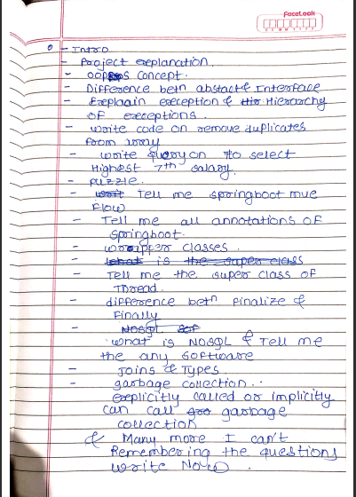

GEP Solutions Pvt. Ltd.

**Swapnil Dilip Pachupate**

Technical Round (R1 Interview):

(By Software Lead - Engg.)

1. Introduce yourself

2. Project Details

3. Your role in project

4. What r u comfortable with Java or .Net

5. So ur project was on MongoDB, Tell me why you choose MongoDB

6. Advantages of MongoDB over MySQL

7. Oops concepts in Java

8. What is abstract class

9. Diff. between Abstract class & Interface

10. What is Sealed class

11. You have used SpringBoot, What are microservices in java

12. Describe microservices architecture

13. Structure of microservices

14. What is RestAPI

15. How do you write RestAPIs

16. Full form of RestAPI

17. What is better - RestAPI or Microservices

18. Diff. between RestAPI & Microservices & explain working/functioning of both

19. Real Life scenario- If u r creating an online shopping site/application. What will u use RestAPIs or Microservices to develope it

20. And why... explain

21. Explain Dependency injection & how do we achieve it

22. What is singleton class

23. How do u create the first instance of singleton class

24. Where do we use singleton classes

25. Explain getInstance() method

26. Explain static methods

27. Diff. between normal & static methods

28. Diff. between static & non-static methods

29. Have you learnt AngularJS (I said No, I have learnt HTML, CSS, JS and Reactjs. Then he asked questions on JS)

30. Explain inheritance in JavaScript. How do u achieve it

31. What is prototype in JavaScript

32. How to change prototype

33. What are JavaScript promises. How do u use them

34. What is state & result in JS promises

35. What are 3 states of promises (Resolved, Reject, Pending)

36. What are synchronous and asynchronous API calls. Diff. between them

37. Adv. & Disadv. of sync & async API calls

38. Which one of them is better to use & why

Leadership Round (R2 Interview):

(By Associate Director - Engg.)

1. Introduce yourself

2. Project Details

3. Your Role in project

4. Why IT over Chemical

5. Explain What is MongoDB

6. What is MongoDB basic architecture

7. How to create collections in MongoDB

8. How do you link backend with MongoDB

9. Explain early binding & late binding in java & C#

10. Adv. & Disadv. of early & late binding

11. What is inner join & outer join. State their differences

12. Java OOPS concepts

13. Explain Sharding & partitioning in MongoDB

14. Fields/ datatypes supported in MongoDB

15. Why MongoDB over MySQL

16. Explain how u have implemented OOPs concepts in ur project

HR round (R3 interview):

1. How are you feeling that u have reached to the last round of ur selection process

2. Introduce yourself

3. Family Background

4. Why IT over Chemical

5. Are u willing to relocate to Mumbai

6. There are a lot many IT companies in Pune (which is nearer to my native place) than Mumbai, then why Mumbai, why not Pune

7. Ur strengths & weakness

8. Past work experience

9. Current journey of CDAC course

10. What I learnt during this period

11. Have u done any research regarding our company (I said yes)

12. Then tell me what u know

13. What are ur long term goals

CRISIL

L1 Round->

Interviewer to me -> share your entire screen.

Introduction

Q .Project and what was your role?

Q .challenges you faced ?

Q .list the errors you faced in project and how you solved it.

Q .what is GetMapping,RestController annotation ?

Q .do you know dto's, did you used it?

Q .you must have used oneToMany relationship in entities.which collection type you used for reference?. ArrayList. Why ArrayList why did you not used hashset?

Q .you were building project remotely right?.then how did you work collaboratively with other team members?

Q .what is interface?. why and when to use interface?. did you used in your project?

Q .Method overloading vs Method overriding.

Q .Write a code to find duplicate elements from an array with their occurance count.

Q .Write a program which covers major operations involved in hashmap.

Q .what is foreign key in database?. -> explanation with practical example

Q .db question->consider a db table having id & name column.write a query to fetch only even id records/rows.

Q. in which scenario you will use self join explain with example and query.

L2 Round ->

Interviewer to me -> share your entire screen. & Open your Resume(cdac resume).

so you have good marks in java. will see.

Introduction

Q .What is method overriding.

Q .what is static keyword.can we use it at class level ?

Q .so we can have static keyword with class inside another class.then how to call its method?.

Q .how can we use new keyword while creating object of static class since static belongs to class area right?

Q .Can we overload static method ?. Can we override static method ?.No->why ? which type of exception you will get?

Q .why is jvm called virtual machine what does that mean?

Q .how to raise custom Exception & how will you achieve it?

Q .Can abstract class have constructor ? if yes then why?. since we can't instantiate it.

Q .why java is called OOP Language. but it has functional programming support right? then why?

Q .write a program to reverse a string without reverse method?

Q .can you write it using while loop

Q .write a code for hashMap iteration using iterator

Q .DB you used ?. okay

Okay lets talk about your project.

Q .Project flow ,role,tech stack ?

Q .Any critical business logic you wrote in your project? can you explain it?

Q .Did you used batch transaction? any scenario ?

Q .industry practices you have implemented while building project?

-------------------------

interviewer->okay i am done from side .do you have any question?

ask question regarding ongoing projects and tech stack.........

tip->don't ask about work life balance.

------------------

**GEP Solutions Pvt. Ltd.**

Name: **Swapnil Dilip Pachupate**

Technical Round (R1 Interview):

(By Software Lead - Engg.)

1. Introduce yourself

2. Project Details

3. Your role in project

4. What r u comfortable with Java or .Net

5. So ur project was on MongoDB, Tell me why you choose MongoDB

6. Advantages of MongoDB over MySQL

7. Oops concepts in Java

8. What is abstract class

9. Diff. between Abstract class & Interface

10. What is Sealed class

11. You have used SpringBoot, What are microservices in java

12. Describe microservices architecture

13. Structure of microservices

14. What is RestAPI

15. How do you write RestAPIs

16. Full form of RestAPI

17. What is better - RestAPI or Microservices

18. Diff. between RestAPI & Microservices & explain working/functioning of both

19. Real Life scenario- If u r creating an online shopping site/application. What will u use RestAPIs or Microservices to develope it

20. And why... explain

21. Explain Dependency injection & how do we achieve it

22. What is singleton class

23. How do u create the first instance of singleton class

24. Where do we use singleton classes

25. Explain getInstance() method

26. Explain static methods

27. Diff. between normal & static methods

28. Diff. between static & non-static methods

29. Have you learnt AngularJS (I said No, I have learnt HTML, CSS, JS and Reactjs. Then he asked questions on JS)

30. Explain inheritance in JavaScript. How do u achieve it

31. What is prototype in JavaScript

32. How to change prototype

33. What are JavaScript promises. How do u use them

34. What is state & result in JS promises

35. What are 3 states of promises (Resolved, Reject, Pending)

36. What are synchronous and asynchronous API calls. Diff. between them

37. Adv. & Disadv. of sync & async API calls

38. Which one of them is better to use & why

39. Few code snippets were also shown on the screen & desired output was asked (both java & DS code snippets)

40. DS based puzzles (e.g. 10 balls are taken, how will u find weight of heaviest ball) Ans:- Divide & conquer approach

Leadership Round (R2 Interview):

(By Associate Director - Engg.)

1. Introduce yourself

2. Project Details

3. Your Role in project

4. Why IT over Chemical

5. Explain What is MongoDB

6. What is MongoDB basic architecture

7. How to create collections in MongoDB

8. How do you link backend with MongoDB

9. Explain early binding & late binding in java & C#

10. Adv. & Disadv. of early & late binding

11. What is inner join & outer join. State their differences

12. Java OOPS concepts

13. Explain Sharding & partitioning in MongoDB

14. Fields/ datatypes supported in MongoDB

15. Why MongoDB over MySQL

16. Explain how u have implemented OOPs concepts in ur project

HR round (R3 interview):

1. How are you feeling that u have reached to the last round of ur selection process

2. Introduce yourself

3. Family Background

4. Why IT over Chemical

5. Are u willing to relocate to Mumbai

6. There are a lot many IT companies in Pune (which is nearer to my native place) than Mumbai, then why Mumbai, why not Pune

7. Ur strengths & weakness

8. Past work experience

9. Current journey of CDAC course

10. What I learnt during this period

11. Have u done any research regarding our company (I said yes)

12. Then tell me what u know

13. What are ur long term goals

Kfintech

1.Introduction

2.abt project

3.oops with real life example

4.polymorphism in detail

5.types of ds

6.how will u del node in linked list

7.Algoritms u know

8.Who is resp for memory management ( .net)

9.Triggers

10. Indexing

11. Features of ReactJs

12. Diff between sql and nosql

Knight Fintech

region :Banglore

1st Round is tech MCQ +Apptitude

2nd Round :Technical Interview

1.directly asking about ur project module and each module functionality & urs role in ur project

2.Flow of your Project

3.Data Structure :what is stack,queue,lnked list? Diff between Array and Linked List

4.Explain Hashmap in details

5.OPPs -Encapsulation and inheritance

6.Explain MVC

7.what is Router and its type(mla ha question ch smjla nhi )

8.types of Data controller?(ha pn smjla nhi)//ntr smjla ki tyani DCL vicharla hota

9.interface and abstract difference

10.method override and overload in c#

11.Rest API vr pn 2 questions hote

12.HTTP request,diff of put and post

13.diff between View and Partial View

14.o/p of one snippet based on delegate

15.WAP to find the sum of even no which are present in array?

Kfintech

(8 LPA/Mumbai,Hyderabad,Bhubaneswar,Ahmedabad/Hybrid[WFO+WFH]) interview round by Prayag Monsara :

1. Introduce yourself

2. Tell me about any 2 best projects you worked on which are applicable for this job.

3. How many members were there in your team? What was your part?

4. Did you implement it in docker?

5. So how did this benefit the clinic?(Project is going to be used by a clinic hence sir asked how it will help the clinic)

6. What was the system/process used previously in the clinic?

7. Why do you used Spring boot?

8. Diff between spring and spring boot

9. Why do we use JPA in spring?

10. How did you send data from java to database? Did you use JDBC? and frontend to java?

11. Which dependencies did you used in Pom.xml?

12. How did you connect your backend to database? What methods did you use?

13. Does spring give dependencies automatically?

14. Have you created any project on react? Have you studied react?

15. What is this second project mentioned in you project on GIS?->BE project? What was your role in it?

16. What is react ?why do we use it?

17. Can browser read JSX directly? or do we need to convert it into anything?

18. Can browser read HTML and CSS directly?

19. What is diff between JSX and html?

20. Why do we use MySQL server?

21. Which language is MySQL written in?

22. Write a query to insert foreign key.

23. What is difference between Database and Table?

24. How to swap numbers without storing them in another temp variable.(just tell approach verbally)

25. How much will you rate yourself in Data structure on a scale of 10?

26. Which language are strong with?

27. Find median of two sorted arrays. Tell me approach first then we will see if we want to go into implementation.

(Do you know what is median? Do you remember mean, mode, median?)

28. What is time complexity and space complexity of your approach?

29. What is n in time complexity? There are 2 arrays here so will the complexity be m+n?

30. If we want to reduce the time complexity and not use another third array to store new array, what approach can we take?

31. Do you have any questions for me?

Kfintech

Kfintech interview round by Prayag Monsara :

1. Introduce yourself

2. Tell me about projects.

3. What was your part in project?

4. What is react ?why do we use it?

5. Can browser read JSX directly? or do we need to convert it into anything?

6. What is diff between JSX and html?

7.what is babbel.

8.difference between virtual dom vs real dom.

9. How much will you rate yourself in Data structure on a scale of 10?

10.which is your favourite datastucture.

11. Find median of two sorted arrays.

12.Tell me approach first .

13.(Do you know what is median? Do you remember mean, mode, median?)

14. What is time complexity and space complexity of your approach?

15. time complexity of sorted array?

16. can you make it more efficient.

17 .how to add 2 sorted array

18 .how see all schema.

19.write query for procedure.

20. why we usetrigger .

21. how to remove column from table write command.

22.diffrence between delete, truncate,drop.

23. explain query with example.

24. sql and mysql diffrence

25. sql - meaning

26. what is relational database.

27.difference between rdbms & dbms

28.sql is case sensitive or not?

29.benifits of using react.

30 .why we use redux.

31.components in react.

32.difference between class component and function component.

33. why we usearrow function.

Kfintech

1. Introduce urself
2. Some scenario base questions on project
3. What is interface
4. What is diff between abstract class and interface
5. Why we need interface
6. Write a program and show an example of interface
7. All above had to do in c#
8. Doubly linear linklist delete operation code
9. A scenario given and a table and asked to write a self join query
10. What is Asp .net
11. Ado.net
12. .net core
13. Configurations
14. What is bundled configuration
15. Who is responsible for memory management in .net
16. Any questions for me

Aragen

Banglore Region (6+2 lpa)

1. Introduction

2. Talk non stop for 5 minutes about what you learnt in 6 months

3. What is Software Development and phases

4. Explain Flavours of Cloud services (IAS, SAS,PAs)

5. Explain public, private hybrid cloud services

6. Explain automation and manual testing

7. What is git, uses of git

8. .net what is ado.net , options for ado.net

9. What is ORM, how it works

10. SQL vs NonSql

11. Big data

12. 3 example of AI used in Mobile

13. Three layers architecture

14. MVC architecture

15. What in Node, React. uses

16. What is jQuery

17. Sync and async functions

18. What is DevOps

19. Difference between microservice and API

Datametica

FirstRound:

Introduce Yourself

Java Features.

Why is java robust?

Streams, functional Interface.

write code to find the frequency of String characters using streams.

same code using collection framework.

Questions related to Hashmap & time complexities.

Types of joins, just explanation of each type.

SecondRound:

What is the motivation to switch from mechanical to IT?

Detail explaination of code which was asked in test & its approach

program to print the characters of string sequentially but its indexes in reversed order.

program to write the binary format of a given number without using inbuilt java API.

SQL query to count the number of events on hourly basis if the timestamp is given in milliseconds.

multi threading.

Applications of queue data structure.

use of queue in BST.

use of oops concepts in your project.

program to implement a queue using an array. dry run for enqueue & dequeue operations.

Nitor

Name =Aman Tekade

Round=L1

1.Tell me about my self

2.why u chnge from electrical to it

3.Then go for which technology u studied in cdac

4.Rate ur self in java sql web .net

5.Why not .net

6.Explain oops

7.Why interface write interface n how interface use for achieve multiple inheritance why their is no ambiguity(20min)

8.Polymorphism compile time (tricky que)

9.What is web technologies

10.Normalization

11.If ur developer what is ur next steps

Lastly do u have any que.

[9:09 pm, 31/10/2022] Bhakti marathi coders: Company Name:- Nitro L1 Round

Name :-Purushottam Shinde

1 . Self Introduction

2.How many module learns in 6 Month?

3.Rate your self in Opps,. net, Java, Database

4.What is Webtechnology?

5.What is foreign Key?

6.Which syntax use in Foreign key?

7.What is polymorphism?

8.How to polymorphism implementing in programming?

9.Explain Project. 4 to 5 question on project.

10.Do you have any Questions?

Name =Onkar mane

Round=L1+L2

1.Tell me about yourself

2.what is your BE Branch

3.why you changing from agriculture to it

3.tell me which technology u studied in cdac , favourite language

4.if given other technology willing to work

5.Oops concepts

6.full depth oops concepts,cross question, programatic examples

7.access specifiers in dot net

8.garbage collection in dot net

9. Java question on string

10.two program first one to print triangle

Second one counting the even odd and prime no

Lastly do u have any que.

Company Name: Nitor Infotech ( 8 lpa)

Technical Interview

1) Introduce yourself

2) Introduce your project, technology used (i said java springboot, react, mysql)

3) Why u go for java and springboot

4) features of springboot

5) What difficulty u faced in project ? How u solved ??

6) have u work on react then rate urself in react

7) use of Hooks? which type of Hooks u know

8) how u pass the multiple data

9) how u passed the data from one class component to another

10) life cycle of react class component

11) do u know about compont did mount, unmount etc.

12) which database u have used in ur project

13) rate urself in mysql

14) diff bet SQL and MySQL

15) 2-3 query based ques

16) rank and dense rank

17) ddl dml dcl tcl commands

18) drop, delete and truncate diff working of each with example

19) oops conepts 4 piller

20) Abstraction - (approx 15-20 min disscussion)

- Interface

- Abstract class

- Abstract methods

21) real time example and one coding example implementation

22) diff runtime polymorphism bet dynamic method dispatch

23) how u achive runtime polymorphism

24) return type and access modifer of overriden mehod

25) how many access specifier in java (i said access modifers - 12 and names)

26) use of final modifier

27) use of abstract

28) diff bet arraylist and vector

29) diff bet hashset and treeset

30) which method used for sorting in treeset

31) what is Binary search ? why we use ? when we use ?

32) what is reflection in java

33) instance and local veriable

34) super keyword

35) diff bet super and this keyword

36) what is constructor chaining ? how we achevied ? how we call ? when we use ?

37) diff bet StringBuffer and StringBuilder

38) Who is efficent StringBuffer or StringBuilder ? why ?

39) Copy constructor

_____________________________

40) 2 codes given for write

1) Reverse the string

2) Print the triangle

code based que approch? why?

Nissan Digital India

Questions asked

1) Explain overriding vs overloading

2) Find the occurrence of each characters in a string

3) Explain your project

4) Which technologies you have used

5) WHy have you chosen Spring boot

6) What are the limitations of java when compared to other products in the market

7) Why do you want to leave Bangalore and come to Trivendrum

8) Are you flexible with other profiles like DevOps, Data engg., Robotic process automation (RPA)

9) Why did you choose IT despite having a degree in mech

Mastercard

TR1:

1. Give a brief introduction about yourself, hobbies, strengths & CDAC project

2.Puzzle1:

Thereare 3 switches outside the room and only one bulb is inside the room and door is close. how will you identify which switch is connected to the door. only one time we can open the door and check.

3. Puzzel2:

There are 3 Ants sitting at the three different corners of an equilateral triangle. Now each ant randomly picks a direction and starts moving along the edge of the triangle. What is the probability that none of the ants collide with each other?

4: which technologies are used in project?

5. What is collections?

6. Discuss about collection API

7. difference between arrayList and LinkedList

8. DIfference between arrayList and StringArray

9.Why springMVC is used in project why not Native java?

10. Why you have used java8 in project?

11. Features of java8

12. How does collection API works?

13. have you use JDBC or any ORM to connect your project with Database?(Ans: Hibernate). the how u connected hibernate with database?

16.what is use used for frontend of project?

17. Tell any scenario where we can use arrarylist & scenario for stringlist

18. What is JRE,JDK.JVM

19. What is singleton class? How you can write that?

20.What is serialization?

21. protected access specifier- where it can b use? scope?

22.Difference between Interface and Class

23. Difference between interface and abstract class

24.Hibernate configruations

25. There is patient table(column: patientid, patient name) & address table(columns : addressid, Address). Address are available is address table but it is not visible to patient. write an sql query to find patientname whose address is not visible.

26. java program

array1 =0,1,2,3,4,5,6

array2=0,2,4,6

write a program to find smallest amoung them

27: which datastructre you will use to find smallest?(Ans: bubble sort)

28: time complexity of bubble sort?

29: Rate yourself between 0 to 5 in writing MySQL query

29: how can you find out which MySQL version is installed on your laptop? command to find out MySql version?

Company:Mastercard TR1

Name: Nikita Kulkarni

Questions:

1)Introduce yourself.

2)How to prevent overriding in Inheritance.

3)How to prevent a class from extending by another class

4)What is class Variables.

5)What is instance variables.

6)What is difference between static and non-static variables.

7)What is compile time exception and run time exception(with examples).

8)What is use of Super keyword?

9)What is try catch block?

10)What is difference between throw and throws clause.

11)if we declare a same name variable in super class and child class. Then to which variable precedance will go first?

12)What is lambda expression?

13)what is difference between comparable and comparator.

14)What is chaining?

15)What is collections?

16)What is spring boot and why it is used?

17)Configuration annotation.

18)Service annotation.

19)how to create an object in simple java and spring boot application?

20)What is difference between Array and Arraylist?

21) What is Hash Collision.

22)How to calculate hash values.

23)Are you a team player or individual one?

24)rate yourself in java out of 5.

25)create a class human and define some fields and methods in that.

26)if you have assigned a difficult task in company, what is your approach towards that task?

27)Any questions for me?

Mastercard

1st Round-technical

1) Introduce Yourself.

2) Tell me about your project.

3) Explain the Oops concepts with real life examples.

4) What is difference between final, finally and finalize?

5) Diffrence between string,stringBuffer,StringBuilder.

6) Given two strings: String str1="abc"; String str2=new String("abc");

7) How many objects will get created and what exactly happens behind referencing to string pool.

8) What is equals() and hashcode() method.

9) Difference between equals() and == operator.

11) Can we change syntax of main method-public static void main(String[] args)

12) Why main method is static?

13) What is thread? How can we implement it?

14) Difference between ArrayList and Linked list.

15) Which annotations did you use in your project?

16) What is significance of @Autowired annotation?

17) Why @RequestMapping annotation is used?

18) What is MVC?

19) SQL query to find 3rd Maximum salary from employee table.

20) Which are the different joins? Explain.

21) Given two tables,given a scenario and asked which join to use for the same.

22) Asked two programs:

Reverse a string

Palindrome (input as int)

2nd Round -Technical+HR

1) Briefly Introduce Yourself.

2) Tell me about your project in detail.

3) You done this project in group.So how members worked on it?

4)On which part you specifically worked?

Explaining that part.

5)Did you use postman while developing your application?

6)So what is get,post,put,delete?

7)Which one is your favourite frontend or backend?(some discussion on same)

8)Given a puzzle:

You have 9 coins which all looks exactly same.In those coins 8 are of the same weight and 1 is lesser in weight than others.You have a old type Taraju.So you have to find out the coin which is less in weight.But you have only two chances to do the same.

9)What are your hobbies?

10)Why you decided to change your field?

More interactive session after that.

Digital Group

What was your project?

// SpringBoot

Why springboot?

Enlist annotations used for project?

explain @component annotation

can we replace @repository annotation by @component?

What is AOP? Can you implement it?

//hibernate

Are you comfortable in hibernate?

Difference between sesssioFactory and hibernatesession?

Explain caching in hibernate?

Loading policy in hibernate

//Spring

What is DI?

What are various ways to achieve?

// DBT

What are diffrent types of joins?

What are indexes in databases?

// React

Why react?

Which component you used (FUNCTIONAL OR CLASS)

Tell me diffrent hooks u have used

//Core JAVA

How can we achieve abstraction in java?

Difference between overloading and overriding

Diiference between list and set

Why we use hashmap

Underlaying datastructure for map

Implementation of hashtable (only explain)

Object classes methods

Why equal and hashcode need tobe overriden in hashtable?

What is comparator and comparabble?

What is immutable class?? examples? can we create our own

JAVA 8 features

How can we implement threads in java?

How can we achieve thread safety?

volatile keyword???

The Digital group

♎: -Tell me about yourself

-Project explanation

-what is public static void main

-maths function

-What is difference between array list and linked list

-write a program of inheritance using exception handling

-difference between join and union

-difference between class and structure

-write sql query which will give you 1st five record from table

-what is remoting

-whai is reflection

-devops

-Why we use sdlc

-what is unit testing

-which is your fav topic in programing

-what is purpose of API

- MVC

♎: Dot net

CTS

CLR

What is garbage collection in dot net

The Digital Group

First Aptitude test

Technical Interview

1.introduce yourself

2.Explain Project

3.what are api you have added in your project ?

4.what is RestController?

5.http methods used?

6.put post differnce?

7.how do you secured api?

8.java 8 ?features

9. streams?

10.lamda expression

11.write a program using lamda expression (java 8 features) find out students from class 12 and having minimum marks?

12.String s1="Mayur";

String s2=new String("Mayur");

differnce between this two?

s1==s2 output

s1.equals output

13.multithreading ?

14.ways of creating thread ?

15.invoke method of thread?

16.how thread interact between them ?

17.wait and sleep differnce ?

18.object class method ?

19.mysql and nosql differnce?

20.all mysql joins ?

21.what is oops;

22.explain polymorphism using example in java and real life ?

HR Interview

1. Introduction Other than Technical Skills?

2.what is food technology?(my B.tech degree)

3.explain more about your b.tech degree ?

4.subject of b.tech degree?

5.family background?

6.location ?

7.Are you fesible to work in hybrid mode ?

8.technolgy flexiblity?flexible to work int UK shift(12 to 9pm) ?

Aragen Life Science

2 technical round

1.Explain what u learned in 6 months of cdac in 5min

2.tell me about personality ..what makes you different from others

3.which language do you prefer java or dotnet

(I said java then all ques were on dotnet)

4.What aspdot net?

5.What is WCF?

6.Have u used rest api in asp dotnet?

7.What are masterpages?

8.What is webfarm and web gardening?

9.Diff between class and interface?

10.Diff between api and microservice

11.What is MSIB?

12.what is razor?

2nd round was a presentation for 10min

Topic- approach for web development using asp dotnet core

Reflexis

Round1:

``````

1. How to achieve encapsulation? how does encapsulation help?

2. How to achieve abstraction?

3. Interface vs abstract class

4. Write mysql query to find maximum salaries according to employee levels.(used group by level)

empId level sal

1 level1 20000

2 level2 30000

3 level1 4000

5. In above, also print corresponding empId. Told me the answer:

SELECT empId, sal from employee e JOIN (SELECT level, salary from employees group by level) as c where e.sal = c.sal AND e.level=c.level

6. Consider an array of n numbers between 0-100. How will you sort them? (Told me to not use pre-existing algorithms)

7. Explain your database of project in DETAIL (10 min on this). (Asked to explain without showing on screen)

8. Java 8 features

9. use stream api to filter employees with salary higher than 10000 in a list and put them into another list.

10. Can we make our own custom checked exception?

Round2:

```````

1. Given two arrays, one array is subset of other. Larger array contains only one extra element. Find the extra element.

public static void main(String[] args) {

int[] A = {3,6,2,4};

int[] B = {6,2,5,4,3};

int uniqueElement=0;

boolean x= false;

for(int i=0; i<B.length; i++){

for(int j=0; j< A.length; j++){

if(B[i]==A[j]){

uniqueElement= 0;

break;

}

if(j== A.length-1) {

uniqueElement=B[i];

System.out.println(uniqueElement);

x=true;

break;

}

if(x==true) {

break;

}

}

}

}

2. What is springboot? Write employee rest controller class and write a get method to get a list of employees.

3. throw vs throws

4. what is finally keyword used for?

5. what is try, catch? can we have try without catch? catch without try? finally without catch?

6. can we have multiple try blocks in a method?

7. try{return 10;}catch{return 20;}finally{return 30;} WHat is returned?

8. Did you use git in your project?

9. Hobbies, family background etc.

Reflexis

Tech interview round :

- Intro

- Reason behind switching career option

- Engineering project details

- Cdac project flow

- Contribution in project

- Hibernate: how it works

- Authentication in project

- How will you make sure that duplicate data will not be stored in your project database

- why springboot

- javascript === and == difference and snippet related to this.

- array vs arraylist

- 2 programs

- sql query. Questions on view

Round 1 : Duration 1hr (All Basic Questions)

1.Introction, why swaitch from mech to IT?

2.What is Encapsulation,how data hiding is achived by it?

3.how you build your project explain from beginning.

4. why you used mysql? why not Oracle?

5. project sql query- find count of all patinets who have subscribed Gold Health Plan

select count(*)

from patinets

group by healthPlan

having healthPlan="Gold"

6. How many tables in your project

7. what will you do if you have to insert 1 lakh records (from file) in database from front end

8. Write code for Fibonachi series

9. What is Microservice? what are the advantages?

10.what is AOP?

Round2: Duration 50mins

1. Introduction- family, hobbies

2. Explain project, have you deployed it? how? show and explain dokcerfile and dockercompose file

3. How you manage codes if there where 4 memebers? git commands?

2. What is springboot? what you use from spring boot in your project.

3. throw vs throws what is difference

4. can we throw Nullpointer exception

5. what is finally keyword used for?

6. finally without catch? can we write multiple finally blocks?

7. what is final where we can use it?

8. Consider below example

public static final List<Emp> empList=new ArrayList<>();

can we add records in empList as it is final and you said we cannot change value of final variable?

Ans. Yes we can add elements, since here empList ref is constant and it is initialized with ArrayList<> instance, now this empList cannot refere to other instance of any List as it is final, it can only point to obj of ArraList with which we have initialized it.

But we can add elements in ArrayList as by doing this ArrayList obj will not change.

9. Consider List of Emplees as List<Emp> empList having 100 employees, now create new List and add only those employees whose salary is greater than 100 .

List<Emp> newEmpList=new ArrayList<>();

empList.foreach(e->if(e.sal>100) newEmpList.add(e));

can you do it using stream?

empList.stream().filter(e->e.sal>100).collect(Collectors.toList());

10. Given two arrays, one array is subset of other. Larger array contains only one extra element. Find the extra element.

public static void main(String[] args) {

int[] A = {3,6,2,4};

int[] B = {6,2,5,4,3};

boolean flag ;

for(int i=0;i<B.lenght;i++)

{

flag=false;

for(int j=0;j<A.lenght;j++){

if(B[i]==A[j]){

flag=true;

break;

}

}

if(!flag)

System.out.println(B[i]);

}

}

}

11. How will you validate email id in front end ? write regex for it?

Baki basic questions hote ajun

IKS Health

IKS health (6LPA/Mumbai)L1 Technical interview by Ruby Yadav:

Interview Questions:

1. Introduce yourself

2. Do you know c#?

3. OOPS concept

4. Project,project members

5. What are Aggregate functions in SQL?

6. What are different constraints present in SQL?

7. Types of Joins?

8. Update query syntax

9. There are 2 tables: table 1 named employee having columns- employeeid,employeename;

Table 2 named Salary having columns- employeeid, salary, designation

a) Write a query to get name & salary of employee using join

b) Write a query to get sum of salary of all the employee as per their designation(for eg., developer,manager)

10. Write a code to check if the given no. is prime or not.

IKS L1

Intro

brief on project

scenario based questions on project

flow of project

what is role of your in project......explain in detail

which db you used in proj

oops

what is constructor what is use of it

encapsulation vs abstraction

how you will achieve encapsulation and abstraction

how you write interface and if I want use interface with class how to write

2 queries

1 prog on reverse a number

how to update a row in table write query

how to delete a row in table which command is used for it

are you comfortable to learn new technology ..... what is your approch to learn thing

have you any que for me ?

IKS Health Interview:

1)Sql query for second highest salary of employee.

2)Code to write Find Array duplicate element.

3) Code to write find consecutive array duplicate element.

4)Code for find factorial of number.

5)What is the use of Object

Finflux

M2P

(12 LPA/Channai,Banglore/WFO) L1 interview round by Some Java developer having 11+ years experience

on Intervue.io platform(External interviewer) :

1)Intro

2)What did you learn throughout your course curriculum

3)Oops concepts

4)Write a code to iterate any collection using java iterator

5)In which package collection is located?

6)What is iteration basically?

7)Types of iteration

8)What is multithreading?

9) Create list,map,set collections and iterate them

10)how will you iterate map collection without iterator?

11)Any questions for me?

Motifworks

Are SQL ani java vr hote

SQL chya query hotya

Ani tyanche customized tables hote tya vr query karun dyaycha hotya

Mostly project madhe konte tables use kele ahet tya vr

Like group by ani Sub query vr jast house hota

Like i++ chya jagi i-- kele tr ky hoil program madhe hya type

Thode ds che ques

Ani thode changes kele tr ky answer yeil ase

Ani HR che ques

Java madhe pattern wala program hota

Introduction , why mechanical to it

4 Round hote

4th round la gela mhanaje mostly fix aste

Director yeto to gappa marto ani basic que vicharto

3 imp last wala tp asto

Happy Moment konta , frustrating moment konta hya type madhe